Microservices Tutorials -----------

URLS :-
What are microservices?
In order to understand microservices, we need to understand what are monolithic applications and what led us to move from monolithic applications to microservices in recent times.
Monolithic applications
If all the functionalities of a project exists in a single codebase, then that application is known as monolithic application. We all must have designed a monolithic application in our lives in which we were given a problem statement and were asked to design a system with various functionalities. We design our application in various layers like presentation, service and persistence and then deploy that codebase as single jar/war file. This is nothing but a monolithic application where “mono” represents the single codebase containing all the required functionalities.
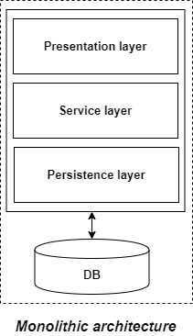
But if we were using monolithic applications already then what led us to microservices?
Disadvantages of Monolithic applications:
It becomes too large in size with time and hence, difficult to manage.
We need to redeploy the whole application even for a small change.
As the size of the application increases, its start-up and deployment time also increases.
For any new developer joining the project, it is very difficult to understand the logic of large Monolithic application even if his responsibility is related to a single functionality.
Even if a single part of the application is facing a large load/traffic, we need to deploy the instances of the whole application in multiple servers. It is very inefficient and takes up more resources unnecessarily. Hence, horizontal scaling is not feasible in monolithic applications.
It is very difficult to adopt any new technology which is well suited for a particular functionality as it affects the whole application, both in terms of time and cost.
It is not very reliable as a single bug in any module can bring down the whole monolithic application.
Advantages of monolithic applications:
Simple to develop relative to microservices where skilled developers are required in order to identify and develop the services.
Easier to deploy as only a single jar/war file is deployed.
Relatively easier and simple to develop in comparison to microservices architecture.
The problems of network latency and security are relatively less in comparison to microservices architecture.
Microservices -
It is an architectural development style in which the application is made up of smaller services communicating with each other directly using light weight protocols like HTTP “Microservices are the small services that work together.”
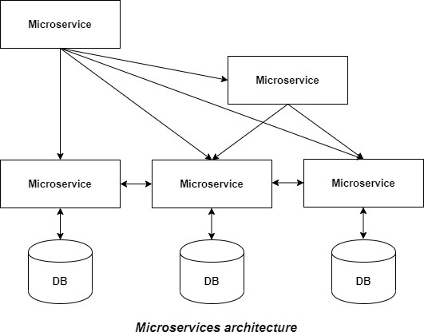
The Microservice architecture has a significant impact on the relationship between the application and the database. Instead of sharing a single database with other microservices, each microservice has its own database. It often results in duplication of some data but having a database per microservice is essential if you want to benefit from this architecture as it ensures loose coupling. Another advantage of having separate database per microservice is that each microservice can use the type of database best suited for its needs.
Advantages of microservices:
It is easy to manage as it is relatively smaller in size.
If there’s any update in one of the microservices, then we need to redeploy only that microservice.
Microservices are self-contained and hence, deployed independently. Their start-up and deployment time are relatively less.
It is very easy for a new developer to on-board the project as he needs to understand only a particular microservice providing the functionality he will be working on and not the whole system.
If a particular microservice is facing a large load because of the users using that functionality in excess then we need to scale out that microservice only. Hence, microservices architecture supports horizontal scaling.
Each microservice can use different technology based on the business requirements.
If a particular microservice goes down due to some bug, then it doesn’t affect other microservices and the whole system remains intact, continues providing other functionalities to the users.
Disadvantages of microservices:
Being a distributed system, it is much more complex than the monolothic applications. Its complexity increases with the increase in number of microservices.
Skilled developers are required to work with microservices architecture which can identify the microservices and manage their inter-communications.
Independent deployment of microservices is complicated.
Microservices are costly in terms of network usage as they need to interact with each other and all these remote calls results into network latency.
Microservices are less secure relative to monolithic applications due to the inter-services communication over the network.
Debugging is difficult as the control flows over many microservices and to point out why and where exactly the error occurred is a difficult task.

Principles of Microservices
Now let’s examine the “must-have” principles of a microservice.
Single responsibility principle
The single responsibility principle is one of the principles defined as part of the SOLID design pattern. It implies that a unit, either a class, a function, or a microservice, should have one and only one responsibility.
At no point in time, one microservice should have more than one responsibility.
Built around business capabilities
Microservices should focus on certain business functions and ensure that it helps in getting things done. A microservice shall never restrict itself from adopting appropriate technology stack or backend database storage which is most suitable for solving the business purpose.
This is often the constraint when we design monolithic applications where we try to solve multiple business solutions with some compromises in some areas. Microservices enable you to choose what’s best for the problem at hand.
You build it, you own it!
Another important aspect of such design is related to responsibilities pre-and-post development. In a large organization, usually one team develops the app location, and after some knowledge transfer sessions it hand over the project to the maintenance team. In microservices, the team which builds the service – owns it, and is responsible for maintaining it in the future.
You build it, you own it !!
This ownership brings developers into contact with the day-to-day operation of their software and they better understand how their built product is used by customers in the real world.
Infrastructure Automation
Preparing and building infrastructure for microservices is another very important need. A service shall be independently deployable and shall bundle all dependencies, including library dependencies, and even execution environments such as web servers and containers or virtual machines that abstract physical resources.
One of the major differences between microservices and SOA is in their level of autonomy. While most SOA implementations provide service-level abstraction, microservices go further and abstract the realization and execution environment.
In traditional application developments, we build a WAR or an EAR, then deploy it into a JEE application server, such as with JBoss, WebLogic, WebSphere, and so on. We may deploy multiple applications into the same JEE container. In an ideal scenario, in the microservices approach, each microservice will be built as a fat Jar, embedding all dependencies and run as a standalone Java process.
Design for Failure
A microservice shall be designed with failure cases in mind. What if the service fails, or go down for some time. These are very important questions and must be solved before actual coding starts – to clearly estimate how service failures will affect the user experience.
Fail fast is another concept used to build fault-tolerant, resilient systems. This philosophy advocates systems that expect failures versus building systems that never fail. Since services can fail at any time, it’s important to be able to detect the failures quickly and, if possible, automatically restore service.
Microservice applications put a lot of emphasis on real-time monitoring of the application, checking both architectural elements (how many requests per second is the database getting) and business relevant metrics (such as how many orders per minute are received). Semantic monitoring can provide an early warning system of something going wrong that triggers development teams to follow up and investigate.
Deploy independently

Microservices are platform agnostic. It means we can design and deploy them independently without affecting the other services
Design Patterns for Microservices
Microservice architecture has become the de facto choice for modern application development. Though it solves certain problems, it is not a silver bullet. It has several drawbacks and when using this architecture, there are numerous issues that must be addressed. This brings about the need to learn common patterns in these problems and solve them with reusable solutions. Thus, design patterns for microservices need to be discussed. Before we dive into the design patterns, we need to understand on what principles microservice architecture has been built:
Scalability
Availability
Resiliency
Independent, autonomous
Decentralized governance
Failure isolation
Auto-Provisioning
Continuous delivery through DevOps
Adhering to the above principles brings several challenges and issues while bring your solution or system to live. Those problems are common for many solutions. Those can overcome with using correct and matching design patterns. There are design patterns for microservices and those can be divided into five Patterns. Each contains many patterns.https://medium.com/edureka/microservices-design-patterns-50640c7bf4a9
https://dzone.com/articles/design-patterns-for-microservices-1

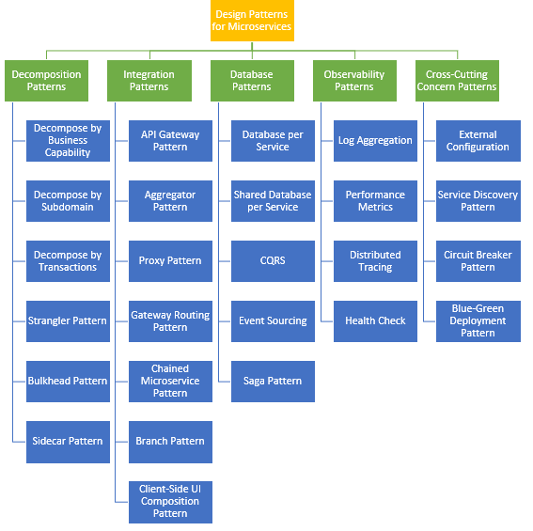
1. Decomposition Patterns
a. Decompose by Business Capability
Problem
Microservices is all about making services loosely coupled, applying the single responsibility principle. However, breaking an application into smaller pieces has to be done logically. How do we decompose an application into small services?
Solution
One strategy is to decompose by business capability. A business capability is something that a business does in order to generate value. The set of capabilities for a given business depend on the type of business. For example, the capabilities of an insurance company typically include sales, marketing, underwriting, claims processing, billing, compliance, etc. Each business capability can be thought of as a service, except it’s business-oriented rather than technical.
b. Decompose by Subdomain
Problem
Decomposing an application using business capabilities might be a good start, but you will come across so-called "God Classes" which will not be easy to decompose. These classes will be common among multiple services. For example, the Order class will be used in Order Management, Order Taking, Order Delivery, etc. How do we decompose them?
Solution
For the "God Classes" issue, DDD (Domain-Driven Design) comes to the rescue. It uses subdomains and bounded context concepts to solve this problem. DDD breaks the whole domain model created for the enterprise into subdomains. Each subdomain will have a model, and the scope of that model will be called the bounded context. Each microservice will be developed around the bounded context.
Note: Identifying subdomains is not an easy task. It requires an understanding of the business. Like business capabilities, subdomains are identified by analyzing the business and its organizational structure and identifying the different areas of expertise.
c. Strangler Pattern
Problem
So far, the design patterns we talked about were decomposing applications for greenfield, but 80% of the work we do is with brownfield applications, which are big, monolithic applications. Applying all the above design patterns to them will be difficult because breaking them into smaller pieces at the same time it's being used live is a big task.
Solution
The Strangler pattern comes to the rescue. The Strangler pattern is based on an analogy to a vine that strangles a tree that it’s wrapped around. This solution works well with web applications, where a call goes back and forth, and for each URI call, a service can be broken into different domains and hosted as separate services. The idea is to do it one domain at a time. This creates two separate applications that live side by side in the same URI space. Eventually, the newly refactored application “strangles” or replaces the original application until finally you can shut off the monolithic application.
2. Integration Patterns
a. API Gateway Pattern
Problem
When an application is broken down to smaller microservices, there are a few concerns that need to be addressed:
How to call multiple microservices abstracting producer information.
On different channels (like desktop, mobile, and tablets), apps need different data to respond for the same backend service, as the UI might be different.
Different consumers might need a different format of the responses from reusable microservices. Who will do the data transformation or field manipulation?
How to handle different type of Protocols some of which might not be supported by producer microservice.
Solution
An API Gateway helps to address many concerns raised by microservice implementation, not limited to the ones above.
An API Gateway is the single point of entry for any microservice call.
It can work as a proxy service to route a request to the concerned microservice, abstracting the producer details.
It can fan out a request to multiple services and aggregate the results to send back to the consumer.
One-size-fits-all APIs cannot solve all the consumer's requirements; this solution can create a fine-grained API for each specific type of client.
It can also convert the protocol request (e.g. AMQP) to another protocol (e.g. HTTP) and vice versa so that the producer and consumer can handle it.
It can also offload the authentication/authorization responsibility of the microservice.
b. Aggregator Pattern
Problem
We have talked about resolving the aggregating data problem in the API Gateway Pattern. However, we will talk about it here holistically. When breaking the business functionality into several smaller logical pieces of code, it becomes necessary to think about how to collaborate the data returned by each service. This responsibility cannot be left with the consumer, as then it might need to understand the internal implementation of the producer application.
Solution
The Aggregator pattern helps to address this. It talks about how we can aggregate the data from different services and then send the final response to the consumer. This can be done in two ways:
1. A composite microservice will make calls to all the required microservices, consolidate the data, and transform the data before sending back.
2. An API Gateway can also partition the request to multiple microservices and aggregate the data before sending it to the consumer.
It is recommended if any business logic is to be applied, then choose a composite microservice. Otherwise, the API Gateway is the established solution.
c. Client-Side UI Composition Pattern
Problem
When services are developed by decomposing business capabilities/subdomains, the services responsible for user experience have to pull data from several microservices. In the monolithic world, there used to be only one call from the UI to a backend service to retrieve all data and refresh/submit the UI page. However, now it won't be the same. We need to understand how to do it.
Solution
With microservices, the UI has to be designed as a skeleton with multiple sections/regions of the screen/page. Each section will make a call to an individual backend microservice to pull the data. That is called composing UI components specific to service. Frameworks like AngularJS and ReactJS help to do that easily. These screens are known as Single Page Applications (SPA). This enables the app to refresh a particular region of the screen instead of the whole page.
3. Database Patterns
a. Database per Service
Problem
There is a problem of how to define database architecture for microservices. Following are the concerns to be addressed:
1. Services must be loosely coupled. They can be developed, deployed, and scaled independently.
2. Business transactions may enforce invariants that span multiple services.
3. Some business transactions need to query data that is owned by multiple services.
4. Databases must sometimes be replicated and sharded in order to scale.
5. Different services have different data storage requirements.
Solution
To solve the above concerns, one database per microservice must be designed; it must be private to that service only. It should be accessed by the microservice API only. It cannot be accessed by other services directly. For example, for relational databases, we can use private-tables-per-service, schema-per-service, or database-server-per-service. Each microservice should have a separate database id so that separate access can be given to put up a barrier and prevent it from using other service tables.
b. Shared Database per Service
Problem
We have talked about one database per service being ideal for microservices, but that is possible when the application is greenfield and to be developed with DDD. But if the application is a monolith and trying to break into microservices, denormalization is not that easy. What is the suitable architecture in that case?
Solution
A shared database per service is not ideal, but that is the working solution for the above scenario. Most people consider this an anti-pattern for microservices, but for brownfield applications, this is a good start to break the application into smaller logical pieces. This should not be applied for greenfield applications. In this pattern, one database can be aligned with more than one microservice, but it has to be restricted to 2-3 maximum, otherwise scaling, autonomy, and independence will be challenging to execute.
c. Command Query Responsibility Segregation (CQRS)
Problem
Once we implement database-per-service, there is a requirement to query, which requires joint data from multiple services — it's not possible. Then, how do we implement queries in microservice architecture?
Solution
CQRS suggests splitting the application into two parts — the command side and the query side. The command side handles the Create, Update, and Delete requests. The query side handles the query part by using the materialized views. The event sourcing pattern is generally used along with it to create events for any data change. Materialized views are kept updated by subscribing to the stream of events.
Event-driven architecture
NOTE: This pattern has been deprecated and replaced by the Saga pattern.
Context
You have applied the Database per Service pattern. Each service has its own database. Some business transactions, however, span multiple service so you need a mechanism to ensure data consistency across services. For example, lets imagine that you are building an e-commerce store where customers have a credit limit. The application must ensure that a new order will not exceed the customer’s credit limit. Since Orders and Customers are in different databases the application cannot simply use a local ACID transaction.

Problem
How to maintain data consistency across services?

Forces
2PC is not an option
Solution
Use an event-driven, eventually consistent approach. Each service publishes an event whenever it update its data. Other service subscribe to events. When an event is received, a service updates its data.

Example
An e-commerce application that uses this approach would work as follows:

The Order Service creates an Order in a pending state and publishes an OrderCreated event.
The Customer Service receives the event and attempts to reserve credit for that Order. It then publishes either a Credit Reserved event or a CreditLimitExceeded event.
The Order Service receives the event from the Customer Service and changes the state of the order to either approved or cancelled
d . Saga Pattern
Problem
When each service has its own database and a business transaction spans multiple services, how do we ensure data consistency across services? For example, for an e-commerce application where customers have a credit limit, the application must ensure that a new order will not exceed the customer’s credit limit. Since Orders and Customers are in different databases, the application cannot simply use a local ACID transaction.
Solution
A Saga represents a high-level business process that consists of several sub requests, which each update data within a single service. Each request has a compensating request that is executed when the request fails. It can be implemented in two ways:
Choreography — When there is no central coordination, each service produces and listens to another service’s events and decides if an action should be taken or not.
Orchestration — An orchestrator (object) takes responsibility for a saga’s decision making and sequencing business logic.
4. Observability Patterns
a. Log Aggregation
Problem
Consider a use case where an application consists of multiple service instances that are running on multiple machines. Requests often span multiple service instances. Each service instance generates a log file in a standardized format. How can we understand the application behavior through logs for a particular request?
Solution
We need a centralized logging service that aggregates logs from each service instance. Users can search and analyze the logs. They can configure alerts that are triggered when certain messages appear in the logs. For example, PCF does have Loggeregator, which collects logs from each component (router, controller, diego, etc...) of the PCF platform along with applications. AWS Cloud Watch also does the same.
ELK, short for Elasticsearch, Logstash, and Kibana, is the most popular open source log aggregation tool on the market. It’s used by Netflix, Facebook, Microsoft, LinkedIn, and Cisco.
b. Performance Metrics
Problem
When the service portfolio increases due to microservice architecture, it becomes critical to keep a watch on the transactions so that patterns can be monitored and alerts sent when an issue happens. How should we collect metrics to monitor application perfomance?
Solution
A metrics service is required to gather statistics about individual operations. It should aggregate the metrics of an application service, which provides reporting and alerting. There are two models for aggregating metrics:
Push — the service pushes metrics to the metrics service e.g. NewRelic, AppDynamics
Pull — the metrics services pulls metrics from the service e.g. Prometheus
There are three monitoring tools are as follows:
Hystrix dashboard
Eureka admin dashboard
Spring boot admin dashboard

c. Distributed Tracing
Problem
In microservice architecture, requests often span multiple services. Each service handles a request by performing one or more operations across multiple services. Then, how do we trace a request end-to-end to troubleshoot the problem?
Solution
We need a service which
Assigns each external request a unique external request id.
Passes the external request id to all services.
Includes the external request id in all log messages.
Records information (e.g. start time, end time) about the requests and operations performed when handling an external request in a centralized service.
Spring Cloud Slueth, along with Zipkin server, is a common implementation.
Tools : OpenTracing , Zipkin , Jaeger
d. Health Check
Problem
When microservice architecture has been implemented, there is a chance that a service might be up but not able to handle transactions. In that case, how do you ensure a request doesn't go to those failed instances? With a load balancing pattern implementation.
Solution
Each service needs to have an endpoint which can be used to check the health of the application, such as /health. This API should o check the status of the host, the connection to other services/infrastructure, and any specific logic.
Spring Boot Actuator does implement a /health endpoint and the implementation can be customized, as well.
5. Cross-Cutting Concern Patterns
a. External Configuration
Problem
A service typically calls other services and databases as well. For each environment like dev, QA, UAT, prod, the endpoint URL or some configuration properties might be different. A change in any of those properties might require a re-build and re-deploy of the service. How do we avoid code modification for configuration changes?
Solution
Externalize all the configuration, including endpoint URLs and credentials. The application should load them either at startup or on the fly.
Spring Cloud config server provides the option to externalize the properties to GitHub and load them as environment properties. These can be accessed by the application on startup or can be refreshed without a server restart.
b. Service Discovery Pattern
Problem
When microservices come into the picture, we need to address a few issues in terms of calling services:
With container technology, IP addresses are dynamically allocated to the service instances. Every time the address changes, a consumer service can break and need manual changes.
Each service URL has to be remembered by the consumer and become tightly coupled.
So how does the consumer or router know all the available service instances and locations?
Solution
A service registry needs to be created which will keep the metadata of each producer service. A service instance should register to the registry when starting and should de-register when shutting down. The consumer or router should query the registry and find out the location of the service. The registry also needs to do a health check of the producer service to ensure that only working instances of the services are available to be consumed through it. There are two types of service discovery: client-side and server-side. An example of client-side discovery is Netflix Eureka and an example of server-side discovery is AWS ALB.
c. Circuit Breaker Pattern
Problem
A service generally calls other services to retrieve data, and there is the chance that the downstream service may be down. There are two problems with this: first, the request will keep going to the down service, exhausting network resources and slowing performance. Second, the user experience will be bad and unpredictable. How do we avoid cascading service failures and handle failures gracefully?
Solution
The consumer should invoke a remote service via a proxy that behaves in a similar fashion to an electrical circuit breaker. When the number of consecutive failures crosses a threshold, the circuit breaker trips, and for the duration of a timeout period, all attempts to invoke the remote service will fail immediately. After the timeout expires the circuit breaker allows a limited number of test requests to pass through. If those requests succeed, the circuit breaker resumes normal operation. Otherwise, if there is a failure, the timeout period begins again.
Netflix Hystrix is a good implementation of the circuit breaker pattern. It also helps you to define a fallback mechanism which can be used when the circuit breaker trips. That provides a better user experience.
d. Blue-Green Deployment Pattern
Problem
With microservice architecture, one application can have many microservices. If we stop all the services then deploy an enhanced version, the downtime will be huge and can impact the business. Also, the rollback will be a nightmare. How do we avoid or reduce downtime of the services during deployment?
Solution
The blue-green deployment strategy can be implemented to reduce or remove downtime. It achieves this by running two identical production environments, Blue and Green. Let's assume Green is the existing live instance and Blue is the new version of the application. At any time, only one of the environments is live, with the live environment serving all production traffic. All cloud platforms provide options for implementing a blue-green deployment. For more details on this topic, check out this article.
There are many other patterns used with microservice architecture, like Sidecar, Chained Microservice, Branch Microservice, Event Sourcing Pattern, Continuous Delivery Patterns, and more. The list keeps growing as we get more experience with microservices. I am stopping now to hear back from you on what microservice patterns you are using.

Challenges of Microservices Architecture
Microservice architecture is more complex than the legacy system. The microservice environment becomes more complicated because the team has to manage and support many moving parts. Here are some of the top challenges that an organization face in their microservices journey:
Bounded Context
Dynamic Scale up and Scale Down
Monitoring
Fault Tolerance
Cyclic dependencies
DevOps Culture
Bounded context: The bounded context concept originated in Domain-Driven Design (DDD) circles. It promotes the Object model first approach to service, defining a data model that service is responsible for and is bound to. A bounded context clarifies, encapsulates, and defines the specific responsibility to the model. It ensures that the domain will not be distracted from the outside. Each model must have a context implicitly defined within a sub-domain, and every context defines boundaries.
In other words, the service owns its data and is responsible for its integrity and mutability. It supports the most important feature of microservices, which is independence and decoupling.
Dynamic scale up and scale down: The loads on the different microservices may be at a different instance of the type. As well as auto-scaling up your microservice should auto-scale down. It reduces the cost of the microservices. We can distribute the load dynamically.
Monitoring: The traditional way of monitoring will not align well with microservices because we have multiple services making up the same functionality previously supported by a single application. When an error arises in the application, finding the root cause can be challenging.
Fault Tolerance: Fault tolerance is the individual service that does not bring down the overall system. The application can operate at a certain degree of satisfaction when the failure occurs. Without fault tolerance, a single failure in the system may cause a total breakdown. The circuit breaker can achieve fault tolerance. The circuit breaker is a pattern that wraps the request to external service and detects when they are faulty. Microservices need to tolerate both internal and external failure.
Cyclic Dependency: Dependency management across different services, and its functionality is very important. The cyclic dependency can create a problem, if not identified and resolved promptly.
DevOps Culture: Microservices fits perfectly into the DevOps. It provides faster delivery service, visibility across data, and cost-effective data. It can extend their use of containerization switch from Service-Oriented-Architecture (SOA) to Microservice Architecture (MSA).
Other challenges of microservices
As we add more microservices, we have to be sure they can scale together. More granularity means more moving parts, which increase complexity.
The traditional logging is ineffective because microservices are stateless, distributed, and independent. The logging must be able to correlate events across several platforms.
When more services interact with each other, the possibility of failure also increases.

Difference between Microservices Architecture (MSA) and Services-Oriented Architecture (SOA)
Microservice Based Architecture (MSA) | Service-Oriented Architecture (SOA)
Microservices uses lightweight protocols such as REST, and HTTP, etc. | SOA supports multi-message protocols.
It focuses on decoupling. | It focuses on application service reusability.
It uses a simple messaging system for communication. | It uses Enterprise Service Bus (ESB) for communication.
Microservices follows "share as little as possible" architecture approach. | SOA follows "share as much as possible architecture" approach.
Microservices are much better in fault tolerance in comparison to SOA. | SOA is not better in fault tolerance in comparison to MSA.
Each microservice have an independent database. | SOA services share the whole data storage.
MSA used modern relational databases. | SOA used traditional relational databases.
MSA tries to minimize sharing through bounded context (the coupling of components and its data as a single unit with minimal dependencies). | SOA enhances component sharing.
It is better suited for the smaller and well portioned, web-based system. | It is better for a large and complex business application environment.

Microservices Monitoring
Monitoring is the control system of the microservices. As the microservices are more complex and harder to understand its performance and troubleshoot the problems. Given the vivid changes to software delivery, it is required to monitor the service. There are five principles of monitoring microservices, as follows:
Monitor container and what's inside them.
Alert on service performance.
Monitor services that are elastic and multi-location.
Monitor APIs.
Monitor the organizational structure.
These principles allow us to address technological changes associated with the microservices and organizational changes related to them.
Microservices Monitoring Tool
There are three monitoring tools are as follows:
Hystrix dashboard
Eureka admin dashboard
Spring boot admin dashboard

Microservice Virtualization
Microservices virtualization is the method to simulate the behavior of specific components in various component-based application like cloud-based application, SOA, and API driven architecture. Service virtualization also reduces cost and save time. By combining service virtualization, an organization can develop the application which can be delivered from various locations and dissimilar environments.
Important URL : https://howtodoinjava.com/microservices/hoverfly-microservices-virtualization-tutorial/
Components of Microservices
There are the following components of microservices:
Spring Cloud Config Server
Netflix Eureka Naming Server
Hystrix Server
Netflix ZuulAPI Gateway Server
Netflix Ribbon
Zipkin Distributed Tracing Server
Spring Cloud Config Server
Spring Cloud Config Server provides the HTTP resource-based API for external configuration in the distributed system. We can enable the Spring Cloud Config Server by using the annotation @EnableConfigServer.
Netflix Eureka Naming Server
Netflix Eureka Server is a discovery server. It provides the REST interface to the outside for communicating with it. A microservice after coming up, register itself as a discovery client. The Eureka server also has another software module called Eureka Client. Eureka client interacts with the Eureka server for service discovery. The Eureka client also balances the client requests.
Hystrix Server
Hystrix server acts as a fault-tolerance robust system. It is used to avoid complete failure of an application. It does this by using the Circuit Breaker mechanism. If the application is running without any issue, the circuit remains closed. If there is an error encountered in the application, the Hystrix Server opens the circuit. The Hystrix server stops the further request to calling service. It provides a highly robust system.
Netflix Zuul API Gateway Server
Netflix Zuul Server is a gateway server from where all the client request has passed through. It acts as a unified interface to a client. It also has an inbuilt load balancer to load the balance of all incoming request from the client.
Netflix Ribbon
Netflix Ribbon is the client-side Inter-Process Communication (IPC) library. It provides the client-side balancing algorithm. It uses a Round Robin Load Balancing:
Load balancing
Fault tolerance
Multiple protocols(HTTP, TCP, UDP)
Caching and Batching
Zipkin Distributed Server
Zipkin is an open-source project m project. That provides a mechanism for sending, receiving, and visualization traces.
One thing you need to be focused on that is port number.
Application | Port
Spring Cloud Config Server | 8888
Netflix Eureka Naming Server | 8761
Netflix Zuul API gateway Server | 8765
Zipkin distributed Tracing Server | 9411
Now Create a Microservice Using Above :

Creating a Simple Microservice

Setting up Spring Cloud Config Server
Step 1: Create a Maven project using Spring Initializr https://start.spring.io/
Step 2: Choose the Spring Boot version 2.2.0 M6 or higher version. Do not choose the snapshot version.
Step 3: Provide the Group name. In our case, com.javatpoint.microservices.
Step 4: Provide the Artifact id. We have provided spring-cloud-config-server.

Connect Spring Cloud Config Server to Local Git Repository
In this section, we are going to learn how to connect spring-cloud-config-server to the local git repository. First, we will find the folder path.
Right-click on git-localconfig-repo -> Properties -> copy the Location label address and paste it into the application.properties file.
Add the annotation @EnableConfigServer in the SpringCloudConfigServerApplication.java file.
Type the following URL in the browser:
localhost:8888/limits-service/default
Introduction to Currency Conversion and Currency Exchange Service
In this section, we will create a couple of microservices: CurrencyCalculationService and CurrencyExchangeService.
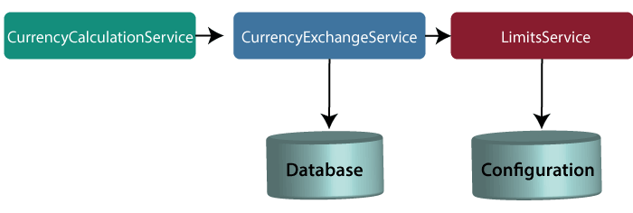
Note: In this tutorial, we have quoted currency conversion service as a currency calculation service. Both the services have the same meaning, so don't be confused.
Let's understand the functionality of these services.
In the above figure, the CurrencyExchangeService uses JPA to talk to the database and returns the exchange value of the specific currency. For example, USD to INR conversion.
When we invoke CurrencyExchangeService, we need to pass two parameters: from(convert from), and to (convert to). For example, if we want to convert currency from USD to INR.
Consider the URL http://localhost:8000/currency-exchange/from/USD/to/INR. It retunes the following response:
{
id: 101,
from: "USD",
to: "INR",
conversionMultiple: 72,
port: 8000
}
The currency exchange service will return what the conversion multiple is. The conversion multiple means 1 USD is equal to 72 INR. The currency converter service uses a currency exchange service. Suppose the currency converter service wants to convert 100 USD to INR. So it will call the currency exchange service and will convert the specified amount that we have provided in the path parameter. For example:
http://localhost:8100/currency-converter/from/USD/to/INR/quantity/100
{
Id: 101,
from: "USD",
to: "INR",
conversionMultiple: 72,
quantity: 100
totalCalculatedAmount: 7200,
port: 8000
}
We will implement these two services in our example using Spring Cloud.
Setting up a currency-exchange-service
Step 1: Open the spring initializer http://start.spring.io.
Step 2: Select the Project: Maven Project, Language: Java, and Spring Boot version 2.2.0 M6 or above. Provide the Group name and Artifact ID. We have provided com.javatpoint.microservices and currency-exchange-service, for group name and Artifact id respectively.
Configure JPA and Initialized Data
In the previous section, we have hardcoded the response for the exchange value. It comes from the database. In this section, we will create a connection to the in-memory database.

Let's see how to connect microservice to the H2 database. Follow the following steps to connect microservice to JPA in-memory database.
Step 1: Open pom.xml of currency-exchange-service and add the following two dependencies.
<dependency>
<groupId>com.h2database</groupId>
<artifactId>h2</artifactId>
<version>1.4.197</version>
<scope>test</scope>
</dependency>
<dependency>
<groupId>org.springframework.boot</groupId>
<artifactId>spring-boot-starter-data-jpa</artifactId>
<version>2.1.3.RELEASE</version>
</dependency>
Creating a JPA Repository
In the previous section, we have created a table in-memory database and saw that all the data is populated correctly. In this section, we will create a repository that returns the response for the service.

Setting up Currency Conversion Microservice
In the previous section, we have created currency-exchange-service. Now we will create a currency-conversion-service that talks to currency-exchange-service.

Invoking currency-exchange-service from currency-conversion-service
We have the currency-exchange-service ready, and we have set up a currency-calculation-service (currency-conversion-service). Now we will invoke the currency exchange service from the currency calculation service.
We use RestTemplate() constructor to invoke an external service. Let's create a RestTemplate and try to invoke currency-exchange-service.
Step 1: Select the currency-conversion-service project.
Step 2: Open the CurrencyConversionController.java and create a new RestTemplate that invokes the currency-exchange-service application.
Step 3: Invoke the getForEntity() method of RestTemplate class.
getForEntity(): It is a method of RestTemplate class that retrieves an entity by using the HTTPGET method for the specified URL. It converts and stores the response in the ResponseEntity. It returns the ResponseEntity.
Parameters: It accepts two parameters:
URL: The URL.
responseType: The type of the return value.
ResponseEntity<CurrencyConversionBean>responseEntity=new RestTemplate().getForEntity("http://localhost:8000/currency-exchange/from/{from}/to/{to}", CurrencyConversionBean.class, uriVariables);

What is Spring WebFlux ?
Spring WebFlux is parallel version of Spring MVC and supports fully non-blocking reactive streams. It support the back pressure concept and uses Netty as inbuilt server to run reactive applications. If you are familiar with Spring MVC programming style, you can easily work on webflux also.
Spring webflux uses project reactor as reactive library. Reactor is a Reactive Streams library and, therefore, all of its operators support non-blocking back pressure. It is developed in close collaboration with Spring.

Using Feign REST Client for Service Invocation
In this section, we will start with one of the popular Spring Cloud Component that is Feign.
Feign
The Feign is a declarative web service (HTTP client) developed by Netflix. Its aim is to simplify the HTTP API clients. It is a Java to HTTP client binder. If you want to use Feign, create an interface, and annotate it. It provides pluggable annotation support, including Feign annotations and JAX-RS annotations.
It is a library for creating REST API clients. It makes web service clients easier. The developers can use declarative annotations to call the REST services instead of writing representative boilerplate code.
Spring Cloud OpenFeign
Spring Cloud OpenFeign provides OpenFeign integrations for Spring Boot apps through auto-configuration and binding to the Spring Environment. Without Feign, in Spring Boot application, we use RestTemplate to call the User service. To use the Feign, we need to add spring-cloud-starter-openfeign dependency in the pom.xml file.
Let’s simplify the previously developed code using Spring Cloud OpenFeign.
In the previous section, one of the things that we had already encountered is when we were developing currency-conversion-service; how difficult it was to call the REST service. There is a lot of manuals that we have to do to call a very simple service. But still we have written a lot of code for it.
When we work with microservices, there will be a lot of calls to other services. We need not to code like the previous one. Feign is a component that solves this problem. Feign makes it easy to invoke other microservices.
The other additional thing that Feign provides is: it integrates with the Ribbon (client-side load balancing framework).
Let's implement the Feign in our project and invoke other microservices using Feign.
Step 1: Select currency-conversion-service project.
Step 2: Open the pom.xml and add the Feign dependency. Feign inherits from the Netflix.
<dependency>
<groupId>org.springframework.cloud</groupId>
<artifactId>spring-cloud-starter-feign</artifactId>
<version>1.4.4.RELEASE</version>
</dependency>
Step 3: Once the dependency is added, enable the Feign to scan the clients by adding the annotation @EnableFeignClients in the CurrencyConversionServiceApplication.java file.
Step 4: Define an attribute in the @EnableFeignClients annotation. The attribute is the name of the package that we want to scan.

Client-Side Load Balancing with Ribbon
Netflix Ribbon
Netflix Ribbon is a Part of Netflix Open Source Software (Netflix OSS). It is a cloud library that provides the client-side load balancing. It automatically interacts with Netflix Service Discovery (Eureka) because it is a member of the Netflix family.
The Ribbon mainly provides client-side load balancing algorithms. It is a client-side load balancer that provides control over the behavior of HTTP and TCP client. The important point is that when we use Feign, the Ribbon also applies.
Features of Ribbon
Load balancing
Fault tolerance
Multiple protocol support in Asynchronous model
Caching and batching
Modules
ribbon: It is an API that integrates load balancing, fault-tolerance, caching, and
ribbon-loadbalancer: It is a Load balancer API that can be used independently or with other modules.
ribbon eureka: It uses Eureka client that provides a dynamic server list for the Spring Cloud.
ribbon-transport: It is a transport client that supports HTTP, TCP, and UDP These protocols use RxNetty with load balancing capability.
ribbon-httpclient: It is a REST client built on top of Apache HttpClient integrated with load balancers.
ribbon-core: It is a Client Configuration API.
Types of Load Balancing:
There are two types of load balancing
Server Side Load Balancing: Server side load balancing is a monolithic It applies between the client and the server. It accepts incoming network, application traffic, and distributes the traffic across the multiple backend servers by using various methods. The middle component is responsible for distributing the client requests to the server.
Client-Side Load Balancing: The client holds the list of server’s IPs so that it can deliver the requests. The client selects an IP from the list, randomly, and forwards the request to the server.
Let's configure the Ribbon server in our project.
Step 1: Go to the project currency-conversion-service.
Step 2: Open pom.xml file and add the ribbon dependency.
<dependency>
<groupId>org.springframework.cloud</groupId>
<artifactId>spring-cloud-starter-netflix-ribbon</artifactId>
</dependency>
After adding the dependency, we need to enable ribbon on the proxy.
Step 3: Open the CurrencyExchangeServiceProxy.java file. Enable Ribbon by adding an annotation @RibbonClient and specify the name of the service which we want to talk to. Ribbon client provide the declarative configuration for a client.
@RibbonClient(name="currency-exchange-service")

Eureka Naming Server
In the previous section, we have configured the Ribbon and distributed the load between the two services. In this section, we will set up the Eureka naming Server.
Naming server
The naming server is a computer application that implements a network service for responding to queries against a directory service.
Eureka naming server
Eureka naming server is a REST-based server that is used in the AWS Cloud services for load balancing and failover of middle-tier services.
Eureka naming server is an application that holds information about all client service applications. Each microservice registers itself with the Eureka naming server. The naming server registers the client services with their port numbers and IP addresses. It is also known as Discovery Server. Eureka naming server comes with the bundle of Spring Cloud. It runs on the default port 8761. It also comes with a Java-based client component, the eureka client, which makes interactions with the service much easier.
The need of naming server
We have another load balancer application, which is known as AWS Cloud. Because of its inherent nature, server ups and down. There is no middle-tier load balancer. Eureka naming server fills the gap between the client and the middle tier load balancer.
Suppose that we want to start another instance of currency-exchange-service that is CurrencyExchangeService3 and launch it on port 8002. Here a question arises, will ribbon be able to distribute the load to it?
If the Ribbon wants to distribute the load to the new server, we need to add it to the configuration. Based on the load, we can increase or decrease the number of instances of the services.
In this section, we will be able to increase or decrease the number of instances dynamically.
If we keep on changing in the CurrencyCalulationService, based on how many CurrenyExchangeService are active right, then, it becomes very difficult to maintain.
The Eureka naming server comes into existence when we want to make maintenance easier. All the instances of all microservices will be register with the Eureka naming server. Whenever a new instance of a microservice comes up, it would register itself with the Eureka naming server. The registration of microservice with the naming server is called Service Registration.
Whenever a service wants to talk with another service, suppose CurrencyCalculationService wants to talk to the CurrencyExchangeService. The CurrencyCalculationService first talk with the Eureka naming server. The naming server provides the instances of CurrencyExchangeService that are currently running. The process of providing instances to other services is called Service Discovery.
Service registration and service discovery are the two important features of the naming server. In the next step, we will set up a Eureka naming server.
Setting up Eureka naming server
There are a lot of steps that are involved in setting up the Eureka naming server are as follows:
Create a component for the Eureka naming server
Update the CurrencyCalculationService to connect to the Eureka naming server
Connect CurrencyExchangeService to the Eureka naming server
Configure the Ribbon
Once the instances of currency-exchange-service are registered with the Eureka naming server, then we will use the Ribbon to find the detail from the naming server. Let’s follow the steps specified above:
Connecting Microservices to Eureka naming server
In this section, we will connect the currency-conversion-service and currency-exchange-service to the Eureka naming server.
First, we will connect the currency-conversion-service.
Step 1: Select the currency-conversion-service project.
Step 2: Open the pom.xml file and add the eureka-client dependency.
<dependency>
<groupId>org.springframework.cloud</groupId>
<artifactId>spring-cloud-starter-netflix-eureka-client</artifactId>
</dependency>
Step 3: Open CurrencyConversionServiceApplication.java file and enable discovery client by using the annotation @EnableDiscoveryClient.
Distributing calls using Eureka and Ribbon
In the previous section, we have registered currency-exchange-service and currency-conversion-service with the Eureka naming server.
When CurrencyCalculationService (currency-conversion-service) invokes CurrencyExchangeService, the Eureka naming server finds the details of the currency-exchange-service.
Instead of hardcoding the URLs for Ribbon, the Ribbon talks to the Eureka naming server and retrieve the details of all the instances of microservices.
Introduction to API Gateways
What is an API Gateway?
An API stands for Application Program Interface. It is a set of instructions, protocols, and tools for building software applications. It specifies how software components should interact.
The API Gateway is a server. It is a single entry point into a system. API Gateway encapsulates the internal system architecture. It provides an API that is tailored to each client. It also has other responsibilities such as authentication, monitoring, load balancing, caching, request shaping and management, and static response handling.
API Gateway is also responsible for request routing, composition, and protocol translation. All the requests made by the client go through the API Gateway. After that, the API Gateway routes requests to the appropriate microservice.
The API Gateway handles the request in one of the two ways:
It routed or proxied the requests to the appropriate service.
Fanning out (spread) a request to multiple services.
The API Gateway can provide each client with a custom API. It also translates between two protocols, such as HTTP, WebSockets, and Web-Unfriendly protocols that are used internally.
Example
The popular example of API Gateway is Netflix API Gateway. The Netflix streaming services are available on hundreds of different kinds of devices such as televisions, set-top boxes, smartphones, tablets, etc. It attempts to provide a one-size-fits-all API for its streaming service.
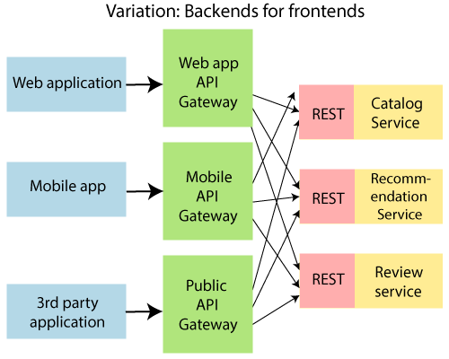
An API Gateway includes:
Security
Caching
API composition and processing
Managing access quotas
API health monitoring
Versioning
Routing
Advantages of API Gateway
The most important advantage of API Gateway is that it encapsulates the internal structure of the application.
Rather than invoking the specific service, the client directly talks to the API Gateway.
It reduces the number of round trips between client and application.
It simplifies the client code.
It reduces coding efforts, makes the application more efficient, decreases errors all at the same time.
It provides each kind of client with a specific API.
Disadvantages
It requires routing rules.
There is a possibility of a single point of failure.
Risk of complexity due to all the API rules are in one place.
Working of API Gateway
In microservices, we route all the requests through an API. We can implement common features like authentication, routing, rate limiting, auditing, and logging in the API Gateway.
Consider a scenario in which we do not want to call a microservice more than five times by a particular client. We can do it as a part of the limit in the API Gateway. We can implement the common features across microservices in the API gateway. The Zuul API Gateway is a popular API Gateway implementation.
We must implement the following features in all the microservices:
Service Aggregation
Authentication, authorization and Security
Rate Limits
Fault Tolerance
Suppose there is an external consumer who wants to call fifteen different services as part of one process. It is better to aggregate those fifteen services and provide one service call for the external consumer. These are the kinds of features that are common across all the microservices. These features are implemented at the level of API.
Instead of allowing microservices to call each other directly, we would do all the calls through API Gateway. API Gateway will take care of common features like authentication, fault tolerance, etc. It also provides aggregation services around all microservices because all calls get routed through the API Gateway.
Zuul API Gateway
What is Zuul?
Zuul Server is an API Gateway application. It handles all the requests and performs the dynamic routing of microservice applications. It works as a front door for all the requests. It is also known as Edge Server.
Zuul is built to enable dynamic routing, monitoring, resiliency, and security. It can also route the requests to multiple Amazon Auto Scaling Groups.
For Example, /api/products are mapped to the product service and /api/user is mapped to the user service. The Zuul Server dynamically routes the requests to the respective backend application.
Why we use Zuul?
The volume and variety of Netflix API traffic sometimes result in production issues that arises quickly and without warning. So we need a system that allows us to rapidly change behavior in order to react to these situations.
Zuul provides a range of different types of filters that allows us to quickly and nimbly apply functionality to our edge service. The filters perform the following functions:
Authentication and Security: It provides authentication requirements for each resource.
Insights and Monitoring: It tracks meaningful data and statistics that give us an accurate view of production.
Dynamic Routing: It dynamically routes the requests to different backed clusters as needed.
Stress Testing: It increases the traffic to a cluster in order to test performance.
Load Shedding: It allocates capacity for each type of request and drops a request that goes over the limit.
Static Response Handling: It builds some responses directly at the edge instead of forwarding them to an internal cluster.
Multi-region Resiliency: It routes requests across AWS regions in order to diversify our ELB usage.
Zuul Components
Zuul 2.x components:
zuul-core: It is a library that contains the core functionality of Zuul 2.0.
zuul-sample: It is a sample driver application for Zuul 2.0
Zuul 1.x components:
zuul-core: It defines the core functionality.
zuul-simple-webapp: A web app that shows a simple example of how to build an application with zuul-core.
zuul-netflix: It is a library that adds other NetflixOSS components to Zuul.
zuul-netflix-webapp: It is a webapp that packages zuul-core and zuul-netflix together.
Setting up Zuul API Gateway Server
There are three steps to set up the Zuul API Gateway:
Create a component for the Zuul API Gateway
Decide the things that the Zuul API Gateway should do
All the important requests are configured to pass through the Zuul API Gateway
Implementing Zuul Logging Filter
In the previous section, we have discussed common functionality that is implemented in API Gateway. We have the Zuul server ready that acts as API Gateway.
In this section, we will implement the logging functionality in the Zuul API Gateway.
Let's implement the logging in the Zuul API Gateway.
Introduction to Distributed Tracing
Distributed Tracing
Distributed tracing is a technique to monitor and profile the applications, especially those built using microservice architecture. It is also known as distributed request tracing. Developers use distributed tracing to debug and optimize the code.
Distribute tracing provides a place where we can see that "what is happening with a specific request?" It is important because there are a variety of components that are involved in the microservices.
If we want to solve a problem or debug a problem, we need a centralized server. So the term distributed tracing comes into existence.
In this section, we will use Spring Cloud Sleuth with Zipkin. Spring Cloud Sleuth assigns a unique Id to each request that we have made. We can trace all the requests based on unique Ids across all the components.
Spring Cloud Sleuth
Spring Cloud Sleuth is a Spring Cloud library that provides the ability to track the progress of subsequent microservices by adding trace and span Ids on the appropriate HTTP request headers. The Sleuth library is based on the MDC (Mapped Diagnostic Context) concept, where we can easily extract values, put to context, and display them in the log.
Zipkin
Zipkin is an open-source, Java-based distributed tracing system. It has a management console that provides a mechanism for sending, receiving, storing, and visualizing traces details of the subsequent services.
With the help of the Zipkin server, we can put all the logs of all the components in the MQ (RabbitMQ). We send the logs to the Zipkin server where the logs consolidate. After doing this, we can monitor different requests. We can also find what is happening to a specific request?
Implementing distributed tracing Using Spring Cloud Sleuth
In this step, we will add Spring Cloud Sleuth for all the microservices. It adds a unique Id to all the requests. It is used to generate and attach the trace Id, span Id to the logs so that tools (Zipkin) can use these ids.
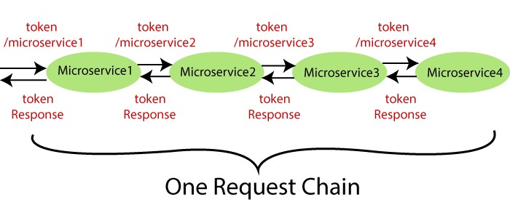
The Spring Cloud Sleuth token has the following components:
Application name: The name of the application that is defined in the properties file.
Trace Id: The Sleuth adds the Trace Id. It remains the same in all services for a given request.
Span Id: The Sleuth also adds the Span Id. It remains the same in a unit of work but different for different services for a given request.
Zipkin Export Flag: It indicates a boolean value. It can be either true or
The following figure shows the Spring Cloud Sleuth token.
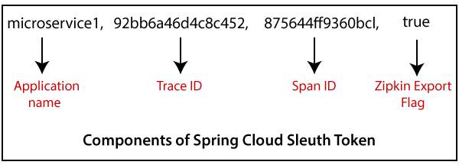
Let's implement the Spring Cloud Sleuth in our projects.
Step 1: Select the project netflix-zuul-api-gateway-server.
Step 2: Open pom.xml and add the Sleuth dependency.
<dependency>
<groupId>org.springframework.cloud</groupId>
<artifactId>spring-cloud-starter-sleuth</artifactId>
</dependency>
Now we need to trace all the requests. If we want to trace all the requests, we would need to create ALWAYS_SAMPLE. We can create a Sampler by using a Bean.
Sampler
Distributed tracing may have a very high volume of data, so the sampling is important in distributed tracing. Spring Cloud Sleuth provides a Sampler strategy. With the help of Sampler, we can implement the sampling algorithm that provides control of the algorithm. By default, we get a procedure that continuously performs the tracing if a span (correlation: is an individual operation) is already active.
But the newly created spans are always marked as non-exportable. If all the applications are running with the Sampler, we can see trace (end-to-end latency graph that is composed of spans) in the log, not in any remote location. By default, Spring Cloud Sleuth sets all spans to non-exportable.
When we export span data to the Zipkin or Spring Cloud Stream, Spring Cloud Sleuth provides AlwaysSampler class that exports everything to the Zipkin. It also provides a PercentageBasedSampler class that samples a fixed fraction of span.
Remember: If you are using Spring 2.0.0 or above versions, use the following Sampler. We have used the same because we are using Spring version 2.2.1.
Installing RabbitMQ Server
RabbitMQ
RabbitMQ is widely deployed open-source message broker software that implements Advanced Message Queuing Protocol (AQMP). It is lightweight and easy to deploy in the cloud. It supports multiple messaging protocols. It can be deployed in a distributed environment to meet high-scale and high-availability requirements. It is modeled on the AMQP standard. The RabbitMQ is written in the Erlang programming language. It is developed on the Open Telecom Platform (OTP) framework for clustering and failover.
RabbitMQ runs on different operating systems and cloud environments. It provides a large number of platforms like Java, .NET, Python, etc.
Advantagesof RabbitMQ
Fast performance
Polyglot (using several languages)
Easy Management
No Erlang knowledge needed
Great documentation
AMQPdefines:
Where to send messages (Routing)
How to get there (Delivery)
What goes in must come out (Fidelity)
Message broker
A message broker sits between the machine and the distributed computing system. Instead of passing the messages directly to the receiver, the messages are first sent to the message broker (RabbitMQ). The message broker orders the messages in an optimized queue and passes them to the receiving machine when the machines are ready to process the messages.
A message might be a command to process an order, run a specified task, a pull request made to a database.
The machine that sends the message is called the producer. The machine that receives the message is called the consumer. The bit in the middle is called thebroker.
Message broker does the following:
Decouple the message publisher and consumer
Store the message
Routing the message
Monitoring and management of message
Transform message format between producer and consum

(Replace RabitMQ by kafka server )
Distributed tracing using Zipkin
What is distributed tracing?
Distributed tracing is a technique used to profile and monitor applications, especially those built using the microservice architecture. Distributed tracing, also called distributed request tracing. IT and DevOps teams can use distributed tracing to monitor applications.
It identifies the failed microservices or the services having performance issues when there are many services call within a request. It is very useful when we need to track the request passing through the multiple microservices. It is also used for measuring the performance of the microservices.
In the previous section, we have installed RabbitMQ that works as middleware. In this section, we will implement the Zipkin Server for Distributed Tracing.
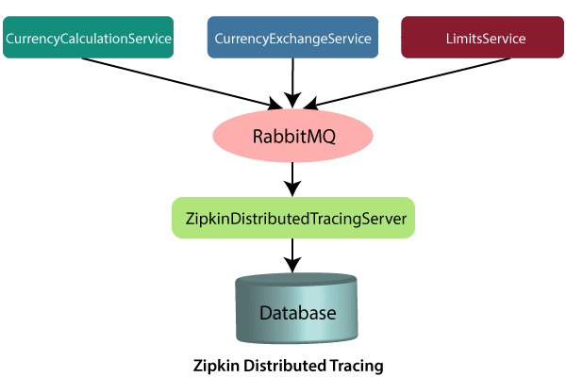
In the above figure, the ZipkinDistributedTracingServer connected to the in-memory database. All the microservices will put the messages in the RabbitMQ server. ZipkinDistributedTracingServer consumes the messages from the RabbitMQ server.
In this section, we will focus on installing ZipkinDistributedTracingServer and will connect it with both the RabbitMQ server and the in-memory database.
Let’s see how to connect the Zipkin server to other servers.
Step 1: Download the Zipkin server.
Search Zipkin quickstart on Google. Click on the link Quickstart OpenZipkin. We get the two options to quick start Zipkin, one is Docker, and the other is Java. But we will use the Java approach.
Step 2: Download the zipkin-server-2.12.9-exec.jar file from https://search.maven.org/remote_content?g=io.zipkin&a=zipkinserver&v=LATEST&c=exec.
Step 3: Copy the JAR file and paste it into any folder or drive. We have pasted the JAR file in the C drive directly.
Step 4: Open the Command Prompt and run the following commands:
C:\> java -jar zipkin-server-2.12.9-exec.jar
The command launches the Zipkin server.
Connecting Microservices to Zipkin
In this section, we will connect microservices to put their trace messages on the RabbitMQ. Once we place the messages on the RabbitMQ, it will be picked up by the Zipkin server.
Let’s connect the currency-conversion-service, currency-exchange-service, and the netflix-zuul-api-gateway-server to the RabbitMQ server.
Step 1: Open the pom.xml file of currency-conversion-service, currency-exchange-service, and the netflix-zuul-api-gateway-server and add the following dependencies:
We want to create a message in the format that it excepts. We need to add Zipkin dependency.

We will send the message to Zipkin that uses amqp message protocol. So we need to add the amqp dependency. Adding the dependency of amqp, we get the connection of RabbitMQ into currency-conversion-service, currency-exchange-service, and the netflix-zuul-api-gateway-server.

Now, we will try to run all the services together.
Using Zipkin UI Dashboard to trace the request
In this step, we will fire a request. But before firing a request, make sure that the five services are running correctly. We must run these five services in the following order. Otherwise, we get errors or incorrect responses.
Implementing Spring Cloud Bus
In this section, when we make the changes in the Git repository, we have to hit multiple instances of the limits-service to refresh the configuration.
We will invoke one URL, and it will reflect all the hundred instances of the microservices. Here we will use Spring Cloud Bus. There are many options available in the Spring Cloud Bus: Apache Kafka, RabbitMQ, etc. In this section, we will use RabbitMQ.
Note: Before moving to the next step, make sure that the RabbitMQ server is running in the background.
Let’s implement the Spring Cloud Bus in limits-service and spring-cloud-config-server.
Step 1: Open the pom.xml file of limits-service and spring-cloud-config-server project. Add the amqp dependency and save the file to reflect the changes.
<dependency>
<groupId>org.springframework.cloud</groupId>
<artifactId>spring-cloud-starter-bus-amqp</artifactId>
</dependency>
Step 2: Open bootstrap.properties file and disable the management security by adding the following statement:
dependency and save the file to reflect the changes.
management.security.enabled=false
Step 3: First, run the SpringCloudConfigServerApplication.java file and then run the two instances of limits-service: LimitsServiceApplication and LimitsServiceApplication8081.
Step 5: Invoke the URL http://localhost:8080/limits. It returns the following response:
dependency and save the file to reflect the changes.
{"maximum":222,"minimum":22}
Now, invoke the URL http://localhost:8081/limits. It also returns the same response.
Step 6: Open the limits-service-qa.properties file and change the minimum value from 22 to 29.
Now we have to commit the changes.
Step 7: Open the Postman and send a POST request with the URL http://localhost:8080/bus/refresh.
Note: If you are using Spring Boot 2.0.0 or above versions, use the following URL:
http://localhost:8080/actuatror/bus-refresh
Step 8: Open the browser and invoke both instances (http://localhost:8080/limits and http://localhost:8081/limits) of limits-service. Both the URLs return the updated value that we have configured in the limits-service-qa.properties file.
{"maximum":222,"minimum":29}
We have seen that the minimum value changes to 29. Here, you can notice that we have not committed the changes in the Git repository manually, but the changes reflect in both instances of limits-service.
Instead of committing the Git repository, we have invoked a URL http://localhost:8080/bus/refresh. All this happening due to Spring Cloud Bus.
In the specific instance, we have run the Spring Cloud Bus over RabbitMQ. When we start the application, it also starts with that. After starting the Spring Cloud Bus, all the microservices registers with the Bus.
When we make changes in configuration, and the changes are called on any of the instances, the microservice sends an event over the Spring Cloud Bus. The Spring Cloud Bus propagates that event to all the microservice instances that are registered with it.
In this section, we have solved the problem of calling multiple instances of microservices.

Fault Tolerance with Hystrix
Microservices must be extremely reliable because they depend on each other. The microservice architecture contains a large number of small microservices. These microservices communicate with each other in order to fulfill their requirements.
The instances of microservices may go up and down frequently. As the number of interactions between microservices increases, the chances of failure of the microservice also increases in the system.
Fault Tolerance
Consider a scenario in which six microservices are communicating with each other. The microservice-5 becomes down at some point, and all the other microservices are directly or indirectly depend on it, so all other services also go down.
The solution to this problem is to use a fallback in case of failure of a microservice. This aspect of a microservice is called fault tolerance.
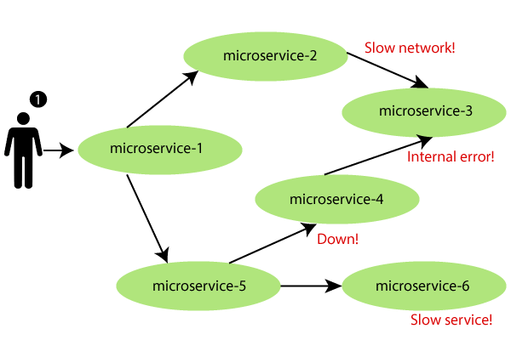
Fault tolerance can be achieved with the help of a circuit breaker. It is a pattern that wraps requests to external services and detects when they fail. If a failure is detected, the circuit breaker opens. All the subsequent requests immediately return an error instead of making requests to the unhealthy service. It monitors and detects the service which is down and misbehaves with other services. It rejects calls until it becomes healthy again.
Hystrix
Hystrix is a library that controls the interaction between microservices to provide latency and fault tolerance. Additionally, it makes sense to modify the UI to let the user know that something might not have worked as expected or would take more time.
Implementing Fault Tolerance with Hystrix
Step 1: Open the pom.xml file of limits-service and add the Hystrix dependency
<dependency>
<groupId>org.springframework.cloud</groupId>
<artifactId>spring-cloud-starter-netflix-hystrix</artifactId>
</dependency>
Step 2: Open LimitsServicesApplication.java file and enable Hystrix by using the annotation @EnableHystrix.

Docker Framework :-
Docker basic commands :

docker run – Runs a command in a new container.
docker start – Starts one or more stopped containers
docker stop – Stops one or more running containers
docker build – Builds an image form a Docker file
docker pull – Pulls an image or a repository from a registry
docker push – Pushes an image or a repository to a registry
docker export – Exports a container’s filesystem as a tar archive
docker exec – Runs a command in a run-time container
docker search – Searches the Docker Hub for images
docker attach – Attaches to a running container
docker commit – Creates a new image from a container’s changes
docker images

The docker ps command shows you all containers that are currently running.
$ docker ps
CONTAINER ID IMAGE COMMAND CREATED STATUS PORTS NAMES
Since no containers are running, we see a blank line. Let's try a more useful variant: docker ps -a
$ docker ps -a
CONTAINER ID IMAGE COMMAND CREATED STATUS PORTS NAMES
305297d7a235 busybox "uptime" 11 minutes ago Exited (0) 11 minutes ago distracted_goldstine
ff0a5c3750b9 busybox "sh" 12 minutes ago Exited (0) 12 minutes ago elated_ramanujan
14e5bd11d164 hello-world "/hello" 2 minutes ago Exited (0) 2 minutes ago thirsty_euclid
So what we see above is a list of all containers that we ran. Do notice that the STATUS column shows that these containers exited a few minutes ago.
docker rm command. Just copy the container IDs from above and paste them alongside the command.
$ docker rm 305297d7a235 ff0a5c3750b9
305297d7a235
ff0a5c3750b9
On deletion, you should see the IDs echoed back to you. If you have a bunch of containers to delete in one go, copy-pasting IDs can be tedious. In that case, you can simply run -
$ docker rm $(docker ps -a -q -f status=exited)
This command deletes all containers that have a status of exited. In case you're wondering, the -q flag, only returns the numeric IDs and -f filters output based on conditions provided. One last thing that'll be useful is the --rm flag that can be passed to docker run which automatically deletes the container once it's exited from. For one off docker runs, --rm flag is very useful.
In later versions of Docker, the docker container prune command can be used to achieve the same effect.
$ docker container prune
WARNING! This will remove all stopped containers.
Are you sure you want to continue? [y/N] y
Deleted Containers:
4a7f7eebae0f63178aff7eb0aa39f0627a203ab2df258c1a00b456cf20063
f98f9c2aa1eaf727e4ec9c0283bcaa4762fbdba7f26191f26c97f64090360

Total reclaimed space: 212 B
Lastly, you can also delete images that you no longer need by running docker rmi.
$ docker run -p 8888:80 prakhar1989/static-site
Nginx is running...

docker pull ubuntu:18.04
The primary purpose of CMD is to tell the container which command it should run when it is started. With that, our Dockerfile is now ready. This is how it looks -
FROM python:3
# set a directory for the app
WORKDIR /usr/src/app
# copy all the files to the container
COPY . .
# install dependencies
RUN pip install --no-cache-dir -r requirements.txt
# define the port number the container should expose
EXPOSE 5000

# run the command
CMD ["python", "./app.py"]
Now that we have our Dockerfile, we can build our image. The docker build
The docker build command is quite simple - it takes an optional tag name with -t and a location of the directory containing the Dockerfile.
$ docker build -t yourusername/catnip .
Sending build context to Docker daemon 8.704 kB
Step 1 : FROM python:3
# Executing 3 build triggers...
Step 1 : COPY requirements.txt /usr/src/app/
---> Using cache
Step 1 : RUN pip install --no-cache-dir -r requirements.txt
---> Using cache
Step 1 : COPY . /usr/src/app
---> 1d61f639ef9e
Removing intermediate container 4de6ddf5528c
Step 2 : EXPOSE 5000
---> Running in 12cfcf6d67ee
---> f423c2f179d1
Removing intermediate container 12cfcf6d67ee
Step 3 : CMD python ./app.py
---> Running in f01401a5ace9
---> 13e87ed1fbc2
Removing intermediate container f01401a5ace9
Successfully built 13e87ed1fbc2
If you don't have the python:3 image, the client will first pull the image and then create your image.
The last step in this section is to run the image and see if it actually works (replacing my username with yours).
$ docker run -p 8888:5000 yourusername/catnip
* Running on http://0.0.0.0:5000/ (Press CTRL+C to quit)
Our Dockerfile for the flask app looks like below -
# start from base
FROM ubuntu:18.04

MAINTAINER Prakhar Srivastav <prakhar@prakhar.me>

# install system-wide deps for python and node
RUN apt-get -yqq update
RUN apt-get -yqq install python3-pip python3-dev curl gnupg
RUN curl -sL https://deb.nodesource.com/setup_10.x | bash
RUN apt-get install -yq nodejs

# copy our application code
ADD flask-app /opt/flask-app
WORKDIR /opt/flask-app

# fetch app specific deps
RUN npm install
RUN npm run build
RUN pip3 install -r requirements.txt

# expose port
EXPOSE 5000

# start app
CMD [ "python3", "./app.py" ]

so let's run docker container ls (which is same as docker ps) and see what we have.

$ docker container ls
CONTAINER ID IMAGE COMMAND CREATED STATUS PORTS NAMES
277451c15ec1 docker.elastic.co/elasticsearch/elasticsearch:6.3.2 "/usr/local/bin/dock…" 17 minutes ago Up 17 minutes 0.0.0.0:9200->9200/tcp, 0.0.0.0:9300->9300/tcp es
So we have one ES container running on 0.0.0.0:9200

docker network ls
Let's first go ahead and create our own network.
$ docker network create foodtrucks-net
2. Difference Between COPY and ADD
At first glance, the COPY and ADD directives look the same. They have the same syntax:

COPY <source> <destination>
ADD <source> <destination>
And both copy files from the host system to the Docker image.

So what's the difference? In short, the ADD directive is more capable than COPY.

While functionally similar, the ADD directive is more powerful in two ways:

It can handle remote URLs
It can auto-extract tar files
Let's look at these more closely.

First, the ADD directive can accept a remote URL for its source argument. The COPY directive, on the other hand, can only accept local files.

Note that using ADD to fetch remote files and copying is not typically ideal. This is because the file will increase the overall Docker image size. Instead, we should use curl or wget to fetch remote files and remove them when no longer needed.

Second, the ADD directive will automatically expand tar files into the image file system. While this can reduce the number of Dockerfile steps required to build an image, it may not be desired in all cases.

Note that the auto-expansion only occurs when the source file is local to the host system.

3. When to Use ADD or COPY
According to the Dockerfile best practices guide, we should always prefer COPY over ADD unless we specifically need one of the two additional features of ADD.

As noted above, using ADD to copy remote files into a Docker image creates an extra layer and increases the file size. If we use wget or curl instead, we can remove the files afterward, and they don't remain a permanent part of the Docker image.

Additionally, since the ADD command automatically expands tar files and certain compressed formats, it can lead to unexpected files being written to the file system in our images.

Docker Compose
Till now we've spent all our time exploring the Docker client. In the Docker ecosystem, however, there are a bunch of other open-source tools which play very nicely with Docker. A few of them are -
Docker Machine - Create Docker hosts on your computer, on cloud providers, and inside your own data center
Docker Compose - A tool for defining and running multi-container Docker applications.
Docker Swarm - A native clustering solution for Docker
Kubernetes - Kubernetes is an open-source system for automating deployment, scaling, and management of containerized applications.
In this section, we are going to look at one of these tools, Docker Compose, and see how it can make dealing with multi-container apps easier.
The background story of Docker Compose is quite interesting. Roughly around January 2014, a company called OrchardUp launched a tool called Fig. The idea behind Fig was to make isolated development environments work with Docker. The project was very well received on Hacker News - I oddly remember reading about it but didn't quite get the hang of it.
The first comment on the forum actually does a good job of explaining what Fig is all about.
So really at this point, that's what Docker is about: running processes. Now Docker offers a quite rich API to run the processes: shared volumes (directories) between containers (i.e. running images), forward port from the host to the container, display logs, and so on. But that's it: Docker as of now, remains at the process level.
While it provides options to orchestrate multiple containers to create a single "app", it doesn't address the management of such group of containers as a single entity. And that's where tools such as Fig come in: talking about a group of containers as a single entity. Think "run an app" (i.e. "run an orchestrated cluster of containers") instead of "run a container".
It turns out that a lot of people using docker agree with this sentiment. Slowly and steadily as Fig became popular, Docker Inc. took notice, acquired the company and re-branded Fig as Docker Compose.
So what is Compose used for? Compose is a tool that is used for defining and running multi-container Docker apps in an easy way. It provides a configuration file called docker-compose.yml that can be used to bring up an application and the suite of services it depends on with just one command. Compose works in all environments: production, staging, development, testing, as well as CI workflows, although Compose is ideal for development and testing environments.
Let's see if we can create a docker-compose.yml file for our SF-Foodtrucks app and evaluate whether Docker Compose lives up to its promise.
The first step, however, is to install Docker Compose. If you're running Windows or Mac, Docker Compose is already installed as it comes in the Docker Toolbox. Linux users can easily get their hands on Docker Compose by following the instructions on the docs. Since Compose is written in Python, you can also simply do pip install docker-compose. Test your installation with -
$ docker-compose --version
docker-compose version 1.21.2, build a133471
Now that we have it installed, we can jump on the next step i.e. the Docker Compose file docker-compose.yml. The syntax for YAML is quite simple and the repo already contains the docker-compose file that we'll be using.
version: "3"
services:
es:
image: docker.elastic.co/elasticsearch/elasticsearch:6.3.2
container_name: es
environment:
- discovery.type=single-node
ports:
- 9200:9200
volumes:
- esdata1:/usr/share/elasticsearch/data
web:
image: prakhar1989/foodtrucks-web
command: python3 app.py
depends_on:
- es
ports:
- 5000:5000
volumes:
- ./flask-app:/opt/flask-app
volumes:
esdata1:
driver: local
Let me breakdown what the file above means. At the parent level, we define the names of our services - es and web. The image parameter is always required, and for each service that we want Docker to run, we can add additional parameters. For es, we just refer to the elasticsearch image available on Elastic registry. For our Flask app, we refer to the image that we built at the beginning of this section.
Other parameters such as command and ports provide more information about the container. The volumes parameter specifies a mount point in our web container where the code will reside. This is purely optional and is useful if you need access to logs, etc. We'll later see how this can be useful during development. Refer to the online reference to learn more about the parameters this file supports. We also add volumes for the es container so that the data we load persists between restarts. We also specify depends_on, which tells docker to start the es container before web. You can read more about it on docker compose docs.
Note: You must be inside the directory with the docker-compose.yml file in order to execute most Compose commands.
Great! Now the file is ready, let's see docker-compose in action. But before we start, we need to make sure the ports and names are free. So if you have the Flask and ES containers running, lets turn them off.
$ docker stop es foodtrucks-web
es
foodtrucks-web

$ docker rm es foodtrucks-web
es
foodtrucks-web
Now we can run docker-compose. Navigate to the food trucks directory and run docker-compose up.
$ docker-compose up
Creating network "foodtrucks_default" with the default driver

let us stop the services from running. We can always bring them back up in just one command. Data volumes will persist, so it’s possible to start the cluster again with the same data using docker-compose up. To destroy the cluster and the data volumes, just type docker-compose down -v.

While we're are at it, we'll also remove the foodtrucks network that we created last time.
$ docker network rm foodtrucks-net
docker network ls
NETWORK ID NAME DRIVER SCOPE
c2c695315b3a bridge bridge local
a875bec5d6fd host host local
ead0e804a67b none null local
Great! Now that we have a clean slate, let's re-run our services and see if Compose does its magic.
$ docker-compose up -d
Recreating foodtrucks_es_1
Recreating foodtrucks_web_1

$ docker container ls
CONTAINER ID IMAGE COMMAND CREATED STATUS PORTS NAMES
f50bb33a3242 prakhar1989/foodtrucks-web "python3 app.py" 14 seconds ago Up 13 seconds 0.0.0.0:5000->5000/tcp foodtrucks_web_1
e299ceeb4caa elasticsearch "/docker-entrypoint.s" 14 seconds ago Up 14 seconds 9200/tcp, 9300/tcp foodtrucks_es_1
So far, so good. Time to see if any networks were created.
$ docker network ls
NETWORK ID NAME DRIVER
c2c695315b3a bridge bridge local
f3b80f381ed3 foodtrucks_default bridge local
a875bec5d6fd host host local
ead0e804a67b none null local
You can see that compose went ahead and created a new network called

https://docker-curriculum.com/
https://www.tutorialspoint.com/docker/docker_working_with_containers.htm
https://www.infoworld.com/article/2607941/docker-tutorial-get-started-with-docker.html# rajivkumar.p100 , 7303182137 Rajeev pal
https://www.interviewbit.com/docker-interview-questions/
Introduction to Docker:
Docker is a very popular and powerful open-source containerization platform that is used for building, deploying, and running applications. Docker allows you to decouple the application/software from the underlying infrastructure.
What is a Container?
A container is a standard unit of software bundled with dependencies so that applications can be deployed fast and reliably b/w different computing platforms.
Docker can be visualized as a big ship (docker) carrying huge boxes of products (containers).
Docker container doesn’t require the installation of a separate operating system. Docker just relies or makes use of the kernel’s resources and its functionality to allocate them for the CPU and memory it relies on the kernel’s functionality and uses resource isolation for CPU and memory, and separate namespaces to isolate the application’s view of the OS (operating system).
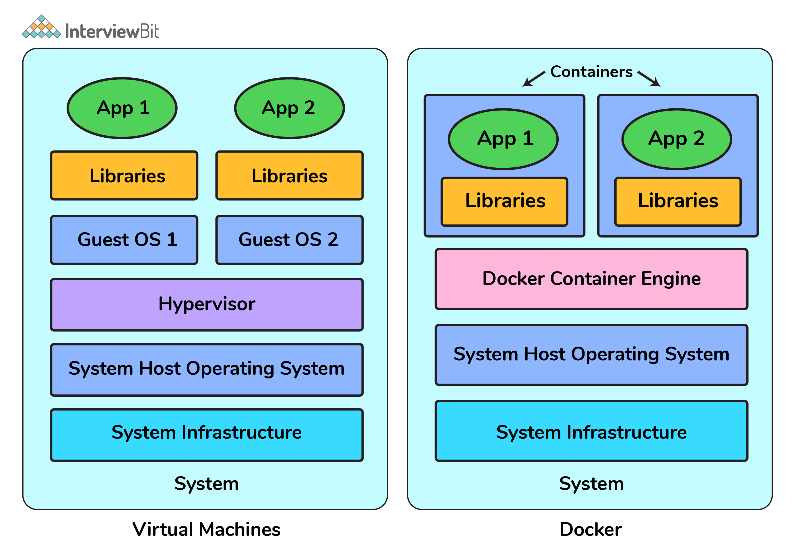

3. What is a DockerFile?
It is a text file that has all commands which need to be run for building a given image.
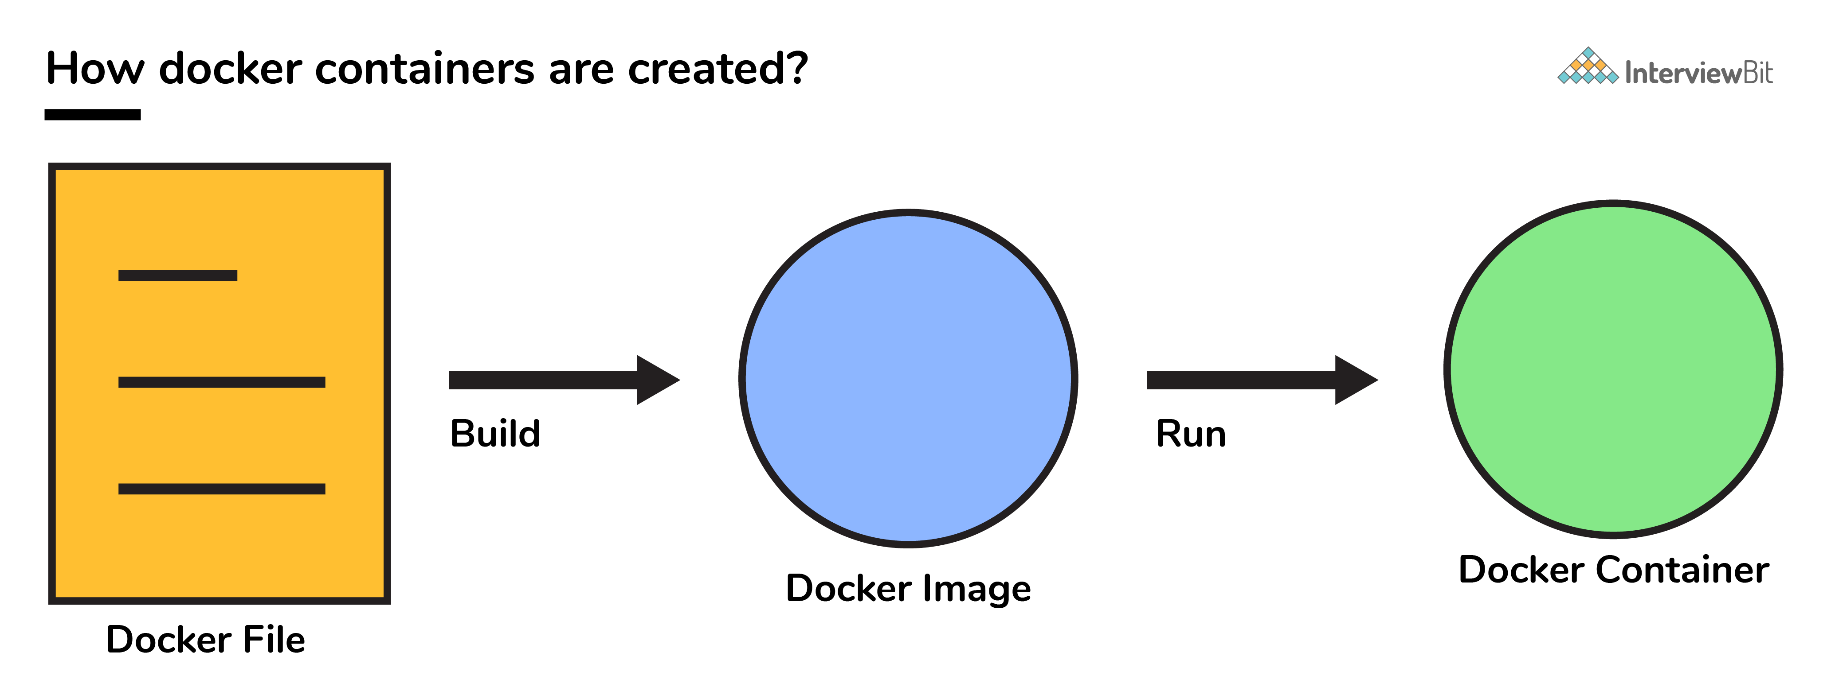
4. Can you tell what is the functionality of a hypervisor?
A hypervisor is a software that makes virtualization happen because of which is sometimes referred to as the Virtual Machine Monitor. This divides the resources of the host system and allocates them to each guest environment installed.
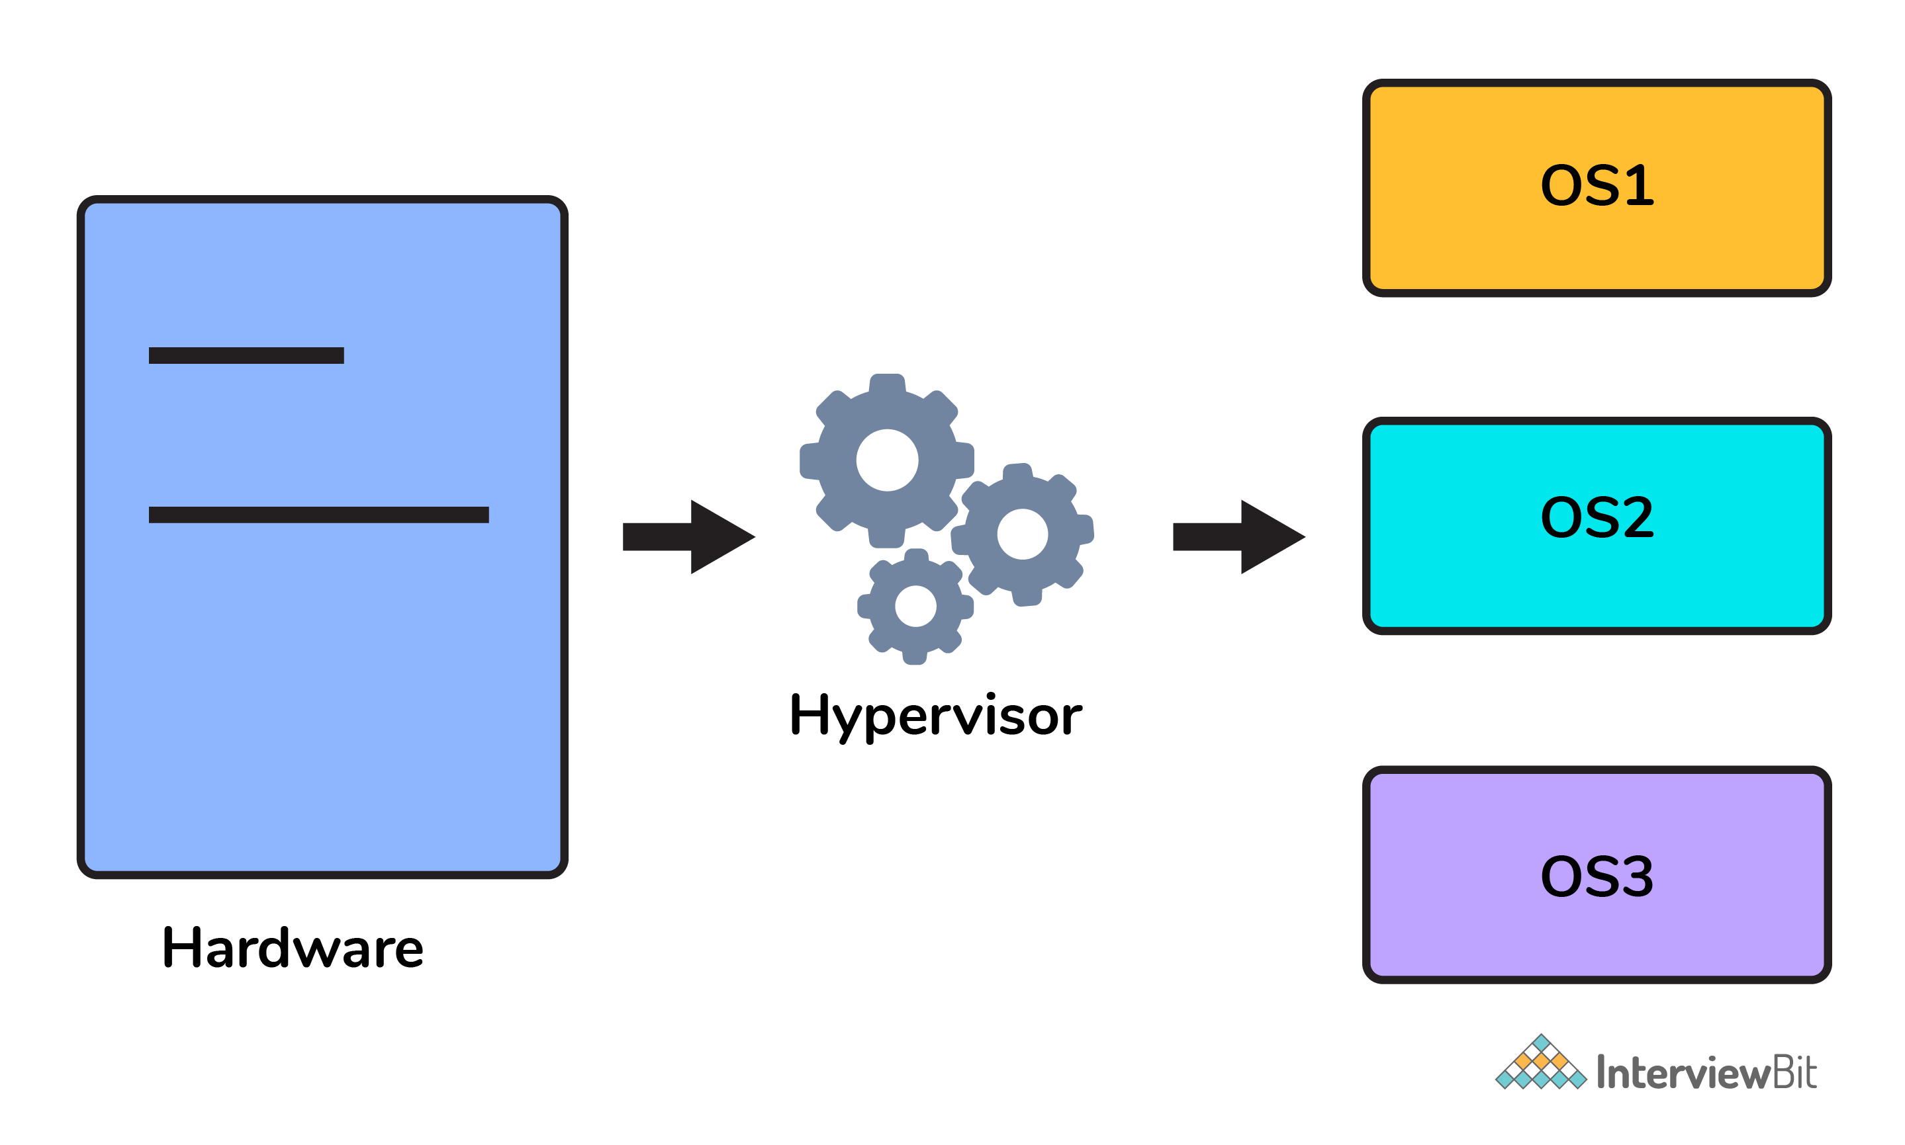
This means that multiple OS can be installed on a single host system. Hypervisors are of 2 types:
1. Native Hypervisor: This type is also called a Bare-metal Hypervisor and runs directly on the underlying host system which also ensures direct access to the host hardware which is why it does not require base OS.
2. Hosted Hypervisor: This type makes use of the underlying host operating system which has the existing OS installed.

10. How many Docker components are there?
There are three docker components, they are - Docker Client, Docker Host, and Docker Registry.
Docker Client: This component performs “build” and “run” operations for the purpose of opening communication with the docker host.
Docker Host: This component has the main docker daemon and hosts containers and their associated images. The daemon establishes a connection with the docker registry.
Docker Registry: This component stores the docker images. There can be a public registry or a private one. The most famous public registries are Docker Hub and Docker Cloud.
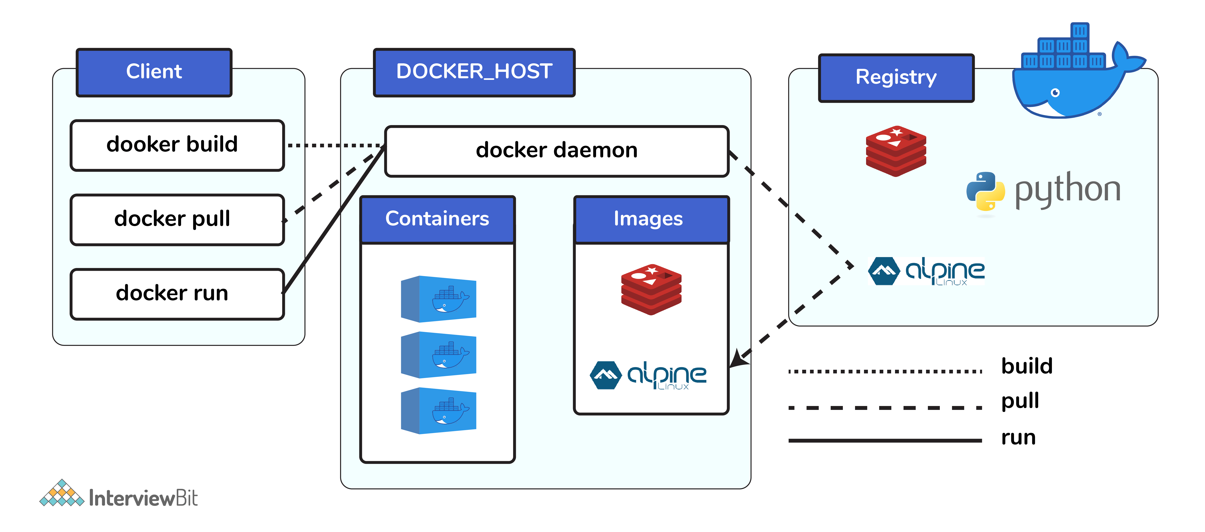
11. What is a Docker Hub?
It is a public cloud-based registry provided by Docker for storing public images of the containers along with the provision of finding and sharing them.
The images can be pushed to Docker Hub through the docker push command.
12. What command can you run to export a docker image as an archive?
This can be done using the docker save command and the syntax is: docker save -o <exported_name>.tar <container-name>
13. What command can be run to import a pre-exported Docker image into another Docker host?
This can be done using the docker load command and the syntax is docker load -i <export_image_name>.tar
14. Can a paused container be removed from Docker?
No, it is not possible! A container MUST be in the stopped state before we can remove it.
15. What command is used to check for the version of docker client and server?
The command used to get all version information of the client and server is the docker version.
To get only the server version details, we can run docker version --format '{{.Server.Version}}'
Docker Intermediate Interview Questions
16. Differentiate between virtualization and containerization.
The question indirectly translates to explaining the difference between virtual machines and Docker containers.
Virtualization | Containerization
This helps developers to run and host multiple OS on the hardware of a single physical server. | This helps developers to deploy multiple applications using the same operating system on a single virtual machine or server.
Hypervisors provide overall virtual machines to the guest operating systems. | Containers ensure isolated environment/ user spaces are provided for running the applications. Any changes done within the container do not reflect on the host or other containers of the same host.
These virtual machines form an abstraction of the system hardware layer this means that each virtual machine on the host acts like a physical machine. | Containers form abstraction of the application layer which means that each container constitutes a different application.
17. Differentiate between COPY and ADD commands that are used in a Dockerfile?
Both the commands have similar functionality, but COPY is more preferred because of its higher transparency level than that of ADD.
COPY provides just the basic support of copying local files into the container whereas ADD provides additional features like remote URL and tar extraction support.
18. Can a container restart by itself?
Yes, it is possible only while using certain docker-defined policies while using the docker run command. Following are the available policies:
1. Off: In this, the container won’t be restarted in case it's stopped or it fails.
2. On-failure: Here, the container restarts by itself only when it experiences failures not associated with the user.
3. Unless-stopped: Using this policy, ensures that a container can restart only when the command is executed to stop it by the user.
4. Always: Irrespective of the failure or stopping, the container always gets restarted in this type of policy.
These policies can be used as:
docker run -dit — restart [restart-policy-value] [container_name]
19. Can you tell the differences between a docker Image and Layer?
Image: This is built up from a series of read-only layers of instructions. An image corresponds to the docker container and is used for speedy operation due to the caching mechanism of each step.
Layer: Each layer corresponds to an instruction of the image’s Dockerfile. In simple words, the layer is also an image but it is the image of the instructions run.
Consider the example Dockerfile below.
FROM ubuntu:18.04
COPY . /myapp
RUN make /myapp
CMD python /myapp/app.py Importantly, each layer is only a set of differences from the layer before it.
- The result of building this docker file is an image. Whereas the instructions present in this file add the layers to the image. The layers can be thought of as intermediate images. In the example above, there are 4 instructions, hence 4 layers are added to the resultant image.
20. What is the purpose of the volume parameter in a docker run command?
The syntax of docker run when using the volumes is: docker run -v host_path:docker_path <container_name>
The volume parameter is used for syncing a directory of a container with any of the host directories. Consider the below command as an example: docker run -v /data/app:usr/src/app myapp
The above command mounts the directory /data/app in the host to the usr/src/app directory. We can sync the container with the data files from the host without having the need to restart it.
This also ensures data security in cases of container deletion. This ensures that even if the container is deleted, the data of the container exists in the volume mapped host location making it the easiest way to store the container data.
21. Where are docker volumes stored in docker?
Volumes are created and managed by Docker and cannot be accessed by non-docker entities. They are stored in Docker host filesystem at /var/lib/docker/volumes/
22. What does the docker info command do?
The command gets detailed information about Docker installed on the host system. The information can be like what is the number of containers or images and in what state they are running and hardware specifications like total memory allocated, speed of the processor, kernel version, etc.
23. Can you tell the what are the purposes of up, run, and start commands of docker compose?
Using the up command for keeping a docker-compose up (ideally at all times), we can start or restart all the networks, services, and drivers associated with the app that are specified in the docker-compose.yml file. Now if we are running the docker-compose up in the “attached” mode then all the logs from the containers would be accessible to us. In case the docker-compose is run in the “detached” mode, then once the containers are started, it just exits and shows no logs.
Using the run command, the docker-compose can run one-off or ad-hoc tasks based on the business requirements. Here, the service name has to be provided and the docker starts only that specific service and also the other services to which the target service is dependent (if any).
- This command is helpful for testing the containers and also performing tasks such as adding or removing data to the container volumes etc.
Using the start command, only those containers can be restarted which were already created and then stopped. This is not useful for creating new containers on its own.
24. What are the basic requirements for the docker to run on any system?
Docker can run on both Windows and Linux platforms.
For the Windows platform, docker atleast needs Windows 10 64bit with 2GB RAM space. For the lower versions, docker can be installed by taking help of the toolbox. Docker can be downloaded from https://docs.docker.com/docker-for-windows/ website.
For Linux platforms, Docker can run on various Linux flavors such as Ubuntu >=12.04, Fedora >=19, RHEL >=6.5, CentOS >=6 etc.
25. Can you tell the approach to login to the docker registry?
Using the docker login command credentials to log in to their own cloud repositories can be entered and accessed.
26. List the most commonly used instructions in Dockerfile?
FROM: This is used to set the base image for upcoming instructions. A docker file is considered to be valid if it starts with the FROM instruction.
LABEL: This is used for the image organization based on projects, modules, or licensing. It also helps in automation as we specify a key-value pair while defining a label that can be later accessed and handled programmatically.
RUN: This command is used to execute instructions following it on the top of the current image in a new layer. Note that with each RUN command execution, we add layers on top of the image and then use that in subsequent steps.
CMD: This command is used to provide default values of an executing container. In cases of multiple CMD commands the last instruction would be considered.
27. Can you differentiate between Daemon Logging and Container Logging?
In docker, logging is supported at 2 levels and they are logging at the Daemon level or logging at the Container level.
Daemon Level: This kind of logging has four levels- Debug, Info, Error, and Fatal.
- Debug has all the data that happened during the execution of the daemon process.
- Info carries all the information along with the error information during the execution of the daemon process.
- Errors have those errors that occurred during the execution of the daemon process.
- Fatal has the fatal errors that occurred during the execution.
Container Level:
- Container level logging can be done using the command: sudo docker run –it <container_name> /bin/bash
- In order to check for the container level logs, we can run the command: sudo docker logs <container_id>
28. What is the way to establish communication between docker host and Linux host?
This can be done using networking by identifying the “ipconfig” on the docker host. This command ensures that an ethernet adapter is created as long as the docker is present in the host.
29. What is the best way of deleting a container?
We need to follow the following two steps for deleting a container:
- docker stop <container_id>
- docker rm <container_id>
30. Can you tell the difference between CMD and ENTRYPOINT?
CMD command provides executable defaults for an executing container. In case the executable has to be omitted then the usage of ENTRYPOINT instruction along with the JSON array format has to be incorporated.
ENTRYPOINT specifies that the instruction within it will always be run when the container starts.
This command provides an option to configure the parameters and the executables. If the DockerFile does not have this command, then it would still get inherited from the base image mentioned in the FROM instruction.
- The most commonly used ENTRYPOINT is /bin/sh or /bin/bash for most of the base images.
As part of good practices, every DockerFile should have at least one of these two commands.
Docker Advanced Interview Questions
31. Can we use JSON instead of YAML while developing docker-compose file in Docker?
Yes! It can be used. In order to run docker-compose with JSON, docker-compose -f docker-compose.json up can be used.
32. How many containers you can run in docker and what are the factors influencing this limit?
There is no clearly defined limit to the number of containers that can be run within docker. But it all depends on the limitations - more specifically hardware restrictions. The size of the app and the CPU resources available are 2 important factors influencing this limit. In case your application is not very big and you have abundant CPU resources, then we can run a huge number of containers.
33. Describe the lifecycle of Docker Container?
The different stages of the docker container from the start of creating it to its end are called the docker container life cycle.
The most important stages are:
Created: This is the state where the container has just been created new but not started yet.
Running: In this state, the container would be running with all its associated processes.
Paused: This state happens when the running container has been paused.
Stopped: This state happens when the running container has been stopped.
Deleted: In this, the container is in a dead state.
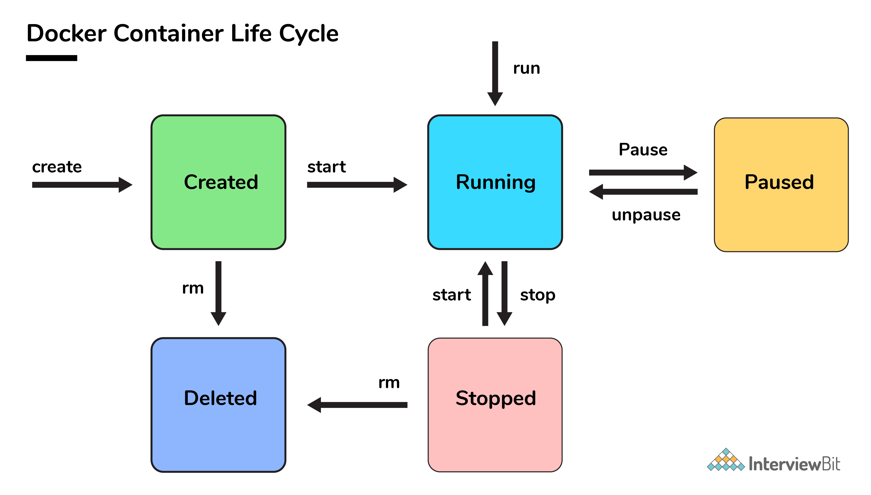
34. How to use docker for multiple application environments?
Docker-compose feature of docker will come to help here. In the docker-compose file, we can define multiple services, networks, and containers along with the volume mapping in a clean manner, and then we can just call the command “docker-compose up”.
When there are multiple environments involved - it can be either dev, staging, uat, or production servers, we would want to define the server-specific dependencies and processes for running the application. In this case, we can go ahead with creating environment-specific docker-compose files of the name “docker-compose.{environment}.yml” and then based on the environment, we can set up and run the application

Prepare Ubuntu Linux for Docker
The first thing to do is obtain the proper version of the kernel and its headers:
$ sudo apt-get install --install-recommends linux-generic-hwe-16.04

$ sudo reboot
You may also need to upgrade other packages in the system afterwards, too:
$ sudo apt-get update
$ sudo apt-get upgrade
Install Docker on Ubuntu
Installation of Docker on CentOS, Fedora, Debian, Ubuntu, and Raspbian Linux distributions is made easy by way of a shell script that you can download from https://get.docker.com/. For that you’ll need the curl command. To get the newest version of curl:
sudo apt-get install curl
Once you have curl installed, fetch the install script and set it running:
curl -s https://get.docker.com | sudo sh
When the script finishes installing, you see a note like the following, with installation details about the version of Docker, both the client and the server components:
IDG
Note the details near the bottom about adding nonroot users to Docker. It’s convenient to do this, but if you do, it’s recommended to create a nonroot user specifically for working with Docker and for no other function. For the sake of this tutorial, though, I’m sticking with using sudo to run Docker by way of a nonprivileged user.
Now you can test out a basic Docker container:
$ sudo docker run -i -t ubuntu /bin/bash
This command downloads the generic Docker Ubuntu image (as per the ubuntu parameter) and run the /bin/bash command in that container. The -i and -t options open standard input and a pseudo TTY respectively.
If it’s successful, you should see the hostname in the command prompt change to something like root@216b04387924:/#, which indicates the ID number (and hostname) of your new running container. To leave, type exit, same as you would to leave any shell session.
You should now have a functional Docker installation on your server. You can test it and get basic information using the docker info command:
$ sudo docker info
The output of the docker info command shows the number of containers and images, among other pertinent information. Note that it may be quite lengthy; this example shows only the last of two pages.
$ sudo docker run -d -p 8080:80 --name apache local:apache_web /usr/local/sbin/startapache.sh
-d - run the container in detached mode (in the background)
-p 8080:80 - map port 8080 of the host to port 80 in the container
docker build -t getting-started .

$ sudo docker run -i -t ubuntu:testing
Et voilà! You have a root shell on a new container built to those specifications. Note that you can also launch the container with this command:
$ sudo docker run -i -t dftest
There are numerous options that can be used in a Dockerfile, such as mapping host directories to containers, setting environment variables, and even setting triggers to be used in future builds. A full list of Dockerfile operators is in the Dockerfile Reference page.
https://towardsdatascience.com/15-docker-commands-you-should-know-970ea5203421

Containers
Use docker container my_command
create — Create a container from an image.
start — Start an existing container.
run — Create a new container and start it.
ls — List running containers.
inspect — See lots of info about a container.
logs — Print logs.
stop — Gracefully stop running container.
kill —Stop main process in container abruptly.
rm— Delete a stopped container.
Images
Use docker image my_command
build — Build an image.
push — Push an image to a remote registry.
ls — List images.
history — See intermediate image info.
inspect — See lots of info about an image, including the layers.
rm — Delete an image.
Misc
docker version — List info about your Docker Client and Server versions.
docker login — Log in to a Docker registry.
docker system prune — Delete all unused containers, unused networks, and dangling images.
Containers
Container Beginnings
The terms create, start, and run all have similar semantics in everyday life. But each is a separate Docker command that creates and/or starts a container. Let’s look at creating a container first.
docker container create my_repo/my_image:my_tag — Create a container from an image.
I’ll shorten my_repo/my_image:my_tag to my_image for the rest of the article.
There are a lot of possible flags you could pass to create.
docker container create -a STDIN my_image
-a is short for --attach. Attach the container to STDIN, STDOUT or STDERR.
Now that we’ve created a container let’s start it.
docker container start my_container — Start an existing container.
Note that the container can be referred to by either the container’s ID or the container’s name.
docker container start my_container

Start
Now that you know how to create and start a container, let’s turn to what’s probably the most common Docker command. It combines both create and start into one command: run.
docker container run my_image — Create a new container and start it. It also has a lot of options. Let’s look at a few.
docker container run -i -t -p 1000:8000 --rm my_image
-i is short for --interactive. Keep STDIN open even if unattached.
-tis short for--tty. Allocates a pseudo terminal that connects your terminal with the container’s STDIN and STDOUT.
You need to specify both -i and -t to then interact with the container through your terminal shell.
-p is short for --port. The port is the interface with the outside world.1000:8000 maps the Docker port 8000 to port 1000 on your machine. If you had an app that output something to the browser you could then navigate your browser to localhost:1000 and see it.
--rm Automatically delete the container when it stops running.
Let’s look at some more examples of run.
docker container kill my_container — Stop one or more running containers abruptly. It’s like pulling the plug on the TV. Prefer stop in most situations.
docker container kill $(docker ps -q) — Kill all running containers.

docker kill cockroach
Then you delete the container with:
docker container rm my_container — Delete one or more containers.
docker container rm $(docker ps -a -q) — Delete all containers that are not running.
Those are the eight essential commands for Docker containers.
To recap, you first create a container. Then, you start the container. Or combine those steps with docker run my_container. Then, your app runs. Yippee!
Then, you stop a container with docker stop my_container. Eventually you delete the container with docker rm my_container.
Now, let’s turn to the magical container-producing molds called images.
Images
Here are seven commands for working with Docker images.
Developing Images
docker image build -t my_repo/my_image:my_tag . — Build a Docker image named my_image from the Dockerfile located at the specified path or URL.
-t is short for tag. Tells docker to tag the image with the provided tag. In this case my_tag .
The . (period) at the end of the command tells Docker to build the image according to the Dockerfile in the current working directory.

Build it
Once you have an image built you want to push it to a remote registry so it can be shared and pulled down as needed. Assuming you want to use Docker Hub, go there in your browser and create an account. It’s free. 😄
This next command isn’t an image command, but it’s useful to see here, so I’ll mention it.
docker login — Log in to a Docker registry. Enter your username and password when prompted.

Push
docker image push my_repo/my_image:my_tag — Push an image to a registry.
Once you have some images you might want to inspect them.

Inspection time
docker image ls — List your images. Shows you the size of each image, too.
docker image history my_image — Display an image’s intermediate images with sizes and how they were created.
docker image inspect my_image — Show lots of details about your image, including the layers that make up the image.
Sometimes you’ll need to clean up your images.
Removing Images
docker image rm my_image — Delete the specified image. If the image is stored in a remote repository, the image will still be available there.
docker image rm $(docker images -a -q) — Delete all images. Careful with this one! Note that images that have been pushed to a remote registry will be preserved — that’s one of the benefits of registries. 😃
Now you know most essential Docker image-related commands. We’ll cover data-related commands in the next article.

Commands are like fruit — nutritious and delicious. Err. Yeah. — Image by silviarita from Pixabay
Misc
docker version — List info about your Docker Client and Server versions.
docker login— Log in to a Docker registry. Enter your username and password when prompted.
docker system prune —Delete all unused containers, unused networks, and dangling images.
docker system prune -a --volumes
-a is short for --all. Delete unused images, not just dangling ones.
--volumes Remove unused volumes. We’ll talk more about volumes in the next article.

https://docker-curriculum.com/#introduction
CI/CD pipeline : -

What is Jenkins?
https://www.guru99.com/download-install-jenkins.html
Jenkins is an open-source Continuous Integration server written in Java for orchestrating a chain of actions to achieve the Continuous Integration process in an automated fashion. Jenkins supports the complete development life cycle of software from building, testing, documenting the software, deploying, and other stages of the software development life cycle.
Jenkins is a widely used application around the world that has around 300k installations and growing day by day. By using Jenkins, software companies can accelerate their software development process, as Jenkins can automate build and test at a rapid rate.
It is a server-based application and requires a web server like Apache Tomcat. The reason Jenkins software became so popular is that of its monitoring of repeated tasks which arise during the development of a project. For example, if your team is developing a project, Jenkins will continuously test your project builds and show you the errors in early stages of your development.
What is Continuous Integration?
Continuous Integration is a process of integrating code changes from multiple developers in a single project many times. The software is tested immediately after a code commit. With each code commit, code is built and tested. If the test is passed, the build is tested for deployment. If the deployment is successful, the code is pushed to production.
This commit, build, test, and deploy is a continuous process and hence the name continuous integration/deployment.
How does Jenkins work?
Jenkins is a server-based application and requires a web server like Apache Tomcat to run on various platforms like Windows, Linux, macOS, Unix, etc. To use Jenkins, you need to create pipelines which are a series of steps that a Jenkins server will take. Jenkins Continuous Integration Pipeline is a powerful instrument that consists of a set of tools designed to host, monitor, compile and test code, or code changes, like:
Continuous Integration Server (Jenkins, Bamboo, CruiseControl, TeamCity, and others)
Source Control Tool (e.g., CVS, SVN, GIT, Mercurial, Perforce, ClearCase and others)
Build tool (Make, ANT, Maven, Ivy, Gradle, and others)
Automation testing framework (Selenium, Appium, TestComplete, UFT, and others)
Real-world case study of Continuous Integration
I am sure all of you aware of old phone Nokia. Nokia used to implement a procedure called nightly build. After multiple commits from diverse developers during the day, the software built every night. Since the software was built only once in a day, it's a huge pain to isolate, identify, and fix the errors in a large code base.
Later, they adopted Continuous Integration approach. The software was built and tested as soon as a developer committed code. If any error is detected, the respective developer can quickly fix the defect.
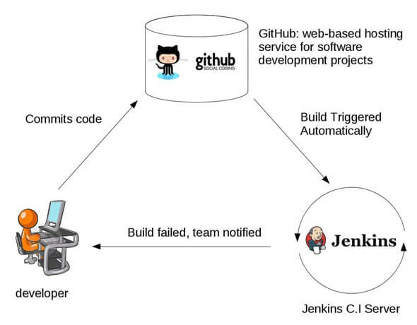
Jenkins Plugins
By default, Jenkins comes with a limited set of features. If you want to integrate your Jenkins installation with version control tools like Git, then you need to install plugins related to Git. In fact, for integration with tools like Maven, Amazon EC2, you need to install respective plugins in your Jenkins.
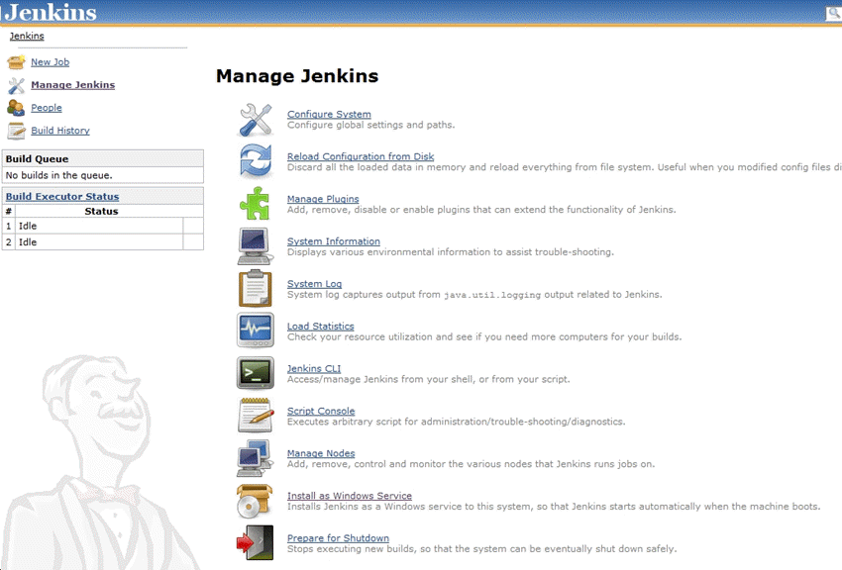Plugins integration in Jenkins
Advantages of using Jenkins
Jenkins is being managed by the community which is very open. Every month, they hold public meetings and take inputs from the public for the development of Jenkins project.
So far around 280 tickets are closed, and the project publishes stable release every three months.
As technology grows, so does Jenkins. So far Jenkins has around 320 plugins published in its plugins database. With plugins, Jenkins becomes even more powerful and feature rich.
Jenkins tool also supports cloud-based architecture so that you can deploy Jenkins in cloud-based platforms.
The reason why Jenkins became popular is that it was created by a developer for developers.
Disadvantages of using Jenkins
Though Jenkins is a very powerful tool, it has its flaws.
Its interface is out dated and not user friendly compared to current UI trends.
Though Jenkins is loved by many developers, it's not that easy to maintain it because Jenkins runs on a server and requires some skills as server administrator to monitor its activity.
One of the reasons why many people don't implement Jenkins is due to its difficulty in installing and configuring Jenkins.
Continuous integrations regularly break due to some small setting changes. Continuous integration will be paused and therefore requires some developer attention.
What is Jenkins Pipeline?
Jenkins Pipeline is a combination of plugins that supports integration and implementation of continuous delivery pipelines. It has an extensible automation server to create simple and complex delivery pipelines as code via pipeline DSL. A Pipeline is a group of events interlinked with each other in a sequence.
What is Continuous Delivery Pipelines? How it Works?
In a Jenkins pipeline, every job or event has some sort of dependency on at least one or more events.
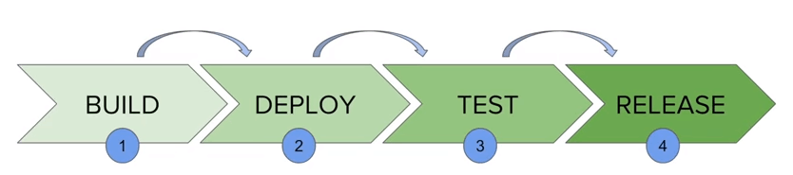Working of Jenkins Continuous Delivery Pipelines
The picture above represents a continuous delivery pipeline in Jenkins. It contains a group of states called build, deploy, test and release. These events are interlinked with each other. Every state has its events, which work in a sequence called a continuous delivery pipeline.
A continuous delivery pipeline is an automated expression to display your process for getting software for version control. Thus, every change made in your software goes through a number of complex processes on its way to being released. It also involves developing the software in a reliable and repeatable manner, and progression of the built software through multiple stages of testing and deployment.
What is a CI/CD pipeline?
A CI/CD pipeline automates the process of software delivery. It builds code, runs tests, and helps you to safely deploy a new version of the software. CI/CD pipeline reduces manual errors, provides feedback to developers, and allows fast product iterations.
CI/CD pipeline introduces automation and continuous monitoring throughout the lifecycle of a software product. It involves from the integration and testing phase to delivery and deployment. These connected practices are referred as CI/CD pipeline.
What is Continuous Integration, Continuous Delivery, and Continuous Deployment?
Continuous integration is a software development method where members of the team can integrate their work at least once a day. In this method, every integration is checked by an automated build to search the error.
Continuous delivery is a software engineering method in which a team develops software products in a short cycle. It ensures that software can be easily released at any time.
Continuous deployment is a software engineering process in which product functionalities are delivered using automatic deployment. It helps testers to validate whether the codebase changes are correct, and it is stable or not.
Stages of a CI/CD pipeline
A CI/CD pipeline is a runnable specification of the steps that any developer should perform to deliver a new version of any software. Failure in each and every stage triggers a notification via email, Slack, or other communication platforms. It enables responsible developers to know about the important issues.
Here are the important Stages of CI/CD pipeline:
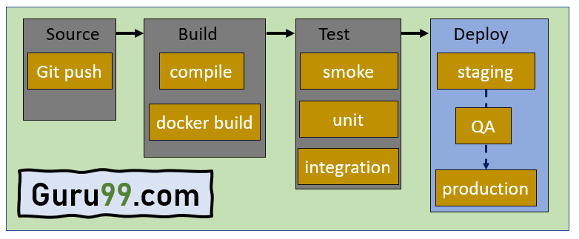Stages of CI/CD pipeline
Source Stage
In the source stage, CI/CD pipeline is triggered by a code repository. Any change in the program triggers a notification to the CI/CD tool that runs an equivalent pipeline. Other common triggers include user-initiated workflows, automated schedules, and the results of other pipelines.
Build Stage
This is the second stage of the CI/CD Pipeline in which you merge the source code and its dependencies. It is done mainly to build a runnable instance of software that you can potentially ship to the end-user.
Programs that are written in languages like C++, Java, C, or Go language should be compiled. On the other hand, JavaScript, Python, and Ruby programs can work without the build stage.
Failure to pass the build stage means there is a fundamental project misconfiguration, so it is better that you address such issue immediately.
Test Stage
Test Stage includes the execution of automated tests to validate the correctness of code and the behaviour of the software. This stage prevents easily reproducible bugs from reaching the clients. It is the responsibility of developers to write automated tests.
Deploy Stage
This is the last stage where your product goes live. Once the build has successfully passed through all the required test scenarios, it is ready to deploy to live server.
Example of CI/CD Pipeline
Here is example of CI/CD pipeline:
Source Code Control: Host code on GitHub as a private repository. This will help you to integrate your application with major services and software.
Continuous integration: Use continuous integration and delivery platform CircleCI and commit every code. When the changes notify, this tool will pull the code available in GitHub and process to build and run the test.
Deploy code to UAT: Configure CitcleCI to deploy your code to AWS UAT server.
Deploy to production: You have to reuse continuous integration steps for deploying code to UAT.
CI/CD pipeline Best Practices
Here is a CI/CD pipeline best practices:
Write up the current development process therefore, you can know the procedures that require to change and one that can be easily automated.
Start off with a small proof of project before going ahead and complete whole development process at once.
Set up a pipeline with more than one stage in which fast fundamental tests run first.
Start each workflow from the same, clean, and isolated environment.
Run open source tools that cover everything from code style to security scanning.
Setup a better code hub to continuously check the quality of your code by running the standard set of tests against every branch.
Peer code review each pull request to solve a problem in a collaborative manner.
You have to define success metrics before you start the transition to CD automation. This will help you to consistently analyze your software, developing progress help refining where needed.
Advantages of CI/CD pipelines
Here are the pros/ benefits of CI/CD Pipeline:
Builds and testing can be easily performed manually.
It can improve the consistency and quality of code.
Improves flexibility and has the ability to ship new functionalities.
CI/CD pipeline can streamline communication.
It can automate the process of software delivery.
Helps you to achieve faster customer feedback.
CI/CD pipeline helps you to increase your product visibility.
It enables you to remove manual errors.
Reduces costs and labour.
CI/CD pipelines can make the software development lifecycle faster.
It has automated pipeline deployment.
A CD pipeline gives a rapid feedback loop starting from developer to client.
Improves communications between organization employees.
It enables developers to know which changes in the build can turn to the brokerage and to avoid them in the future.
The automated tests, along with few manual test runs, help to fix any issues that may arise.
Important CI/CD tools
Here are the important CI/CD tools:
Jenkins

Jenkins is an open-source Continuous Integration server that helps to achieve the Continuous Integration process (and not only) in an automated fashion. Jenkins is free and is entirely written in Java. Jenkins is a widely used application around the world that has around 300k installations and growing day by day.

What is Continuous Integration?
Continuous integration is a software development method where members of the team can integrate their work at least once a day. In this method, every integration is checked by an automated build to search the error.
In continuous integration after a code commit, the software is built and tested immediately. In a large project with many developers, commits are made many times during a day. With each commit code is built and tested. If the test is passed, build is tested for Deployment. If the Deployment is a success, the code is pushed to production. This commit, build, test, and deploy is a continuous process, and hence the name continuous integration/deployment.
What is Continuous Delivery?
Continuous delivery is a software engineering method in which a team develops software products in a short cycle. It ensures that software can be easily released at any time.
The main aim of continuous delivery is to build, test, and release software with good speed and frequency. It helps you to reduce the cost time and risk of delivering changes by allowing for frequent updates in production.
What is Continuous Deployment
Continuous deployment is a software engineering process in which product functionalities are delivered using automatic deployment. It helps testers to validate whether the codebase changes are correct and stable or not.
The team can achieve continuous deployment by relying on infrastructure that automates different testing steps. Once each integration meets this release criteria, the application is updated with a new code.

